The MODerate-resolution Imaging Spectroradiometer (MODIS) Normalized Difference Vegetation Index (NDVI) product is computed from atmospherically corrected bi-directional surface reflectances that have been masked for water, clouds, heavy aerosols, and cloud shadows. The MODIS NDVI 16-Day (MOD13Q1) product is available every 16 days from February 2000 to present. The MOD13Q1 tiles were downloaded from Land Processes Distributed Active Archive Center (LP DAAC), reprojected from the standard MODIS Sinusoidal grid tiling system to UTM and mosaicked to produce this W2W (wall to wall) NDVI dataset.
NDVI is a remotely sensed measurement designed to provide spatially and temporally consistent measurements of the land surface vegetation cover conditions. Healthy green vegetation absorbs solar radiation in visible and reflects solar radiation in the near infrared spectral region as part of photosynthesis process. By exploiting the difference in absorption properties of live vegetation we can calculate a vegetation greenness index a measure of photosynthetic capacity of the land surface cover. NDVI is calculated from the red and near-infrared reflectance in NIR and RED spectral regions as: NDVI = (NIR-RED)/(NIR+RED). NDVI’s value is always between -1 and +1. Higher NDVI values associated with greater density and vegetation greenness of the land surface cover. Water bodies have negative values, while bare earth and snow values are closer to zero. Each NDVI value in this dataset is scaled as integer (NDVI*10,000).
Title | Alberta W2W Normalized Difference Vegetation Index (NDVI)
Sensor and product name | MODIS Terra, MOD13Q1
Data format | Tiff, integer (NDVI*10,000)
Spatial reference | WGS 84
Spatial resolution (metres) | 231.7 m
Spatial coverage (degrees) | 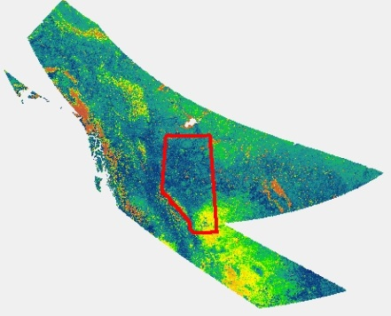  60 N; 48 S; -120 W; -110 E
Temporal resolution | 16-day composite
Temporal coverage | 2000-02-18 - ongoing
Public release | June 1st, 2014

Dataset Release Date: June 1st, 2014
Dataset Release Place: Edmonton AB, Canada
Dataset Publisher: Alberta Biodiversity Monitoring Institute
Online Resource:

