Alberta Biodiversity
Monitoring Institute

www.abmi.ca

Alberta Backfilled Wall-to-Wall Vegetation Layer (Version 5) Metadata

Document Version: June 22, 2015

Acknowledgements
This document was created by Daiyuan Pan, Jim Schieck, and Shawn Morrison.

Disclaimer
These standards and protocols were developed and released by the ABMI. The material in this publication does not imply the expression of any opinion whatsoever on the part of any individual or organization other than the ABMI. Errors, omissions, or inconsistencies in this publication are the sole responsibility of ABMI.

The ABMI assumes no liability in connection with the information products or services made available by the Institute. While every effort is made to ensure the information contained in these products is correct, the ABMI disclaims any liability in negligence or otherwise for any loss or damage which may occur as a result of reliance on any of this material. All information products are subject to change by the ABMI without notice.

Suggested Citation: Alberta Biodiversity Monitoring Institute. 2015. Alberta Backfilled Wall-to-Wall Vegetation Layer (Version 5) Metadata. Alberta Biodiversity Monitoring Institute, Alberta, Canada. Report available at: abmi.ca.

Use of this Material: This publication may be reproduced in whole or in part and in any form for educational, data collection or non-profit purposes without special permission from the ABMI, provided acknowledgement of the source is made. No use of this publication may be made for resale without prior permission in writing from the ABMI.

Contact Information
If you have questions or concerns about this publication, you can contact:
ABMI Information Centre
CW-405 Biological Sciences Centre
University of Alberta
Edmonton, Alberta, Canada, T6G 2E9
Phone: (780) 492-5531
E-mail: abmiinfo@ualberta.ca

Table of Contents

1 Summary 7
2 Background on the Alberta Biodiversity Monitoring Institute 7
3 Source Layers 8
3.1 Vegetation Layers 8
3.2 Wetland Layers 8
3.3 Date of Origin (Stand Age) Layers 9
3.4 Soil Type (Ecosite) Layers 9
3.5 ABMI 2012 Human Footprint Sub-layers 9
4 Creation of Backfilled Layer 9
5 Removal of Human Footprint (‘Backfilling’) 10
5.1 Extended Alberta Vegetation Inventory (AVIE) layer 10
5.1.1 Natural vegetation identification and classification for AVIE layer 10
5.1.2 Origin Year and Origin Type from AVIE 12
5.1.3 Backfilling AVIE layer 12
5.1.4 New water boundaries for backfilled AVIE layer 19
5.1.5 Post cleaning up backfilled AVIE layer 21
5.2 Primary Land and Vegetation Inventory (PLVI) layer 21
5.2.1 Natural vegetation identification and classification for PLVI layer 21
5.2.2 Backfilling the PLVI layer 24
5.2.3 Water boundaries for the backfilled PLVI layer 25
5.2.4 Post cleaning up backfilled PLVI layer 25
5.3 Grassland Vegetation Inventory Layer (GVI) 25
5.3.1 Extended GVI layer 25
5.3.2 Natural vegetation identification and classification for GVI layer 28
5.3.3 Backfilling the GVI layer 30
5.3.4 New Water Boundaries for the Backfilled GVI layer 31
5.3.5 Post cleaning up backfilled GVI layer 31
5.4 Central Parkland Vegetation Inventory (CPVI) 32
5.4.1 Natural Vegetation in CPVI 32
5.4.2 Backfilling the CPVI layer 32
5.4.3 New Water Boundaries for the Backfilled CPVI layer 33
5.4.4 Post cleaning up backfilled CPVI layer 33
5.5 Vegetation in National Parks 33
5.5.1 Wood Buffalo National Park 33
5.5.2 Elk Island National Park 36
5.5.3 Mountain National Parks 36
5.6 Remaining Areas 40
6 Data Additions 41
6.1 Pine (PCT_P) 41
6.1.1 Processing the AVIE layer 41
6.1.2 Processing the AGCC layer 41
6.1.3 Combining layers 42
6.2 Water and Wet Information 42
6.2.1 Alberta CWCS Merged Wetland Inventory 43
6.3 Date of Origin (ORIGIN_YEAR) 44
6.4 Soil Type (SOIL_TYPE) 45
7 Combination of Sub-Layers 47
7.1 Upland and Wetland Habitat Definition 48
7.2 Attribute Table Definitions 50
8 Addition of ABMI 2012 Human Footprint Sub-layers 52

List of Tables

Table 1 Definition of vegetation types derived from the AVIE. 11
Table 2 Backfilling rules for four human footprint types from the AVIE. 12
Table 3 Phase I layer classes and merging rules for the natural vegetation types. 14
Table 4 ABMILC layer classes and the derived natural vegetation types. 15
Table 5 Dominant vegetation type and upland forest type in each natural sub-region (NSRNAME) used for backfilling cutblocks and other human footprint types. 17
Table 6 List of feature types (FEATURE_TY) contained within the Government of Alberta hydropoly layer, and whether they were used to update the boundaries of open water areas in the backfilled layer. 20
Table 7 Buffer sizes (m) used in the stream line layer added to the backfilled layer to improve the accuracy of open water boundaries. 20
Table 8 Definitions of the vegetation types derived from the Primary Land and Vegetation Inventory (PLVI). 22
Table 9 Forest age derived from pioneering tree species successional stage in PLVI. 23
Table 10 Forest age derived from serial tree species succession stage in PLVI. 23
Table 11 Constraints for backfilling human disturbed polygons with their own attribute data in the Primary Land and Vegetation Inventory (PLVI) layer 24
Table 12 Fields added to the attribute table of the Grassland Vegetation Inventory (GVI) “LANDSCAPE_POLYGON” layer 26
Table 13 Definition of Vegetation Types derived from the Grassland Vegetation Inventory (GVI) 28
Table 14 Conversion from the Grassland Vegetation Inventory (GVI) Site Type to the ABMI moisture regime 29
Table 15 Rule set used to backfill Human Footprint based on soil type. 30
Table 16 Ecosite classes in the Wood Buffalo National Park ecosite layer and naming rules for natural vegetation types and backfilled rules for human footprint types 34
Table 17 Vegetation codes in the mountain national parks ecological land classification layer and naming rules for natural vegetation types 36
Table 18 Un-vegetated ecosite codes in the mountain national parks ecological land classification layer and the natural types assigned 39
Table 19 Conversion from the soil drainage in the mountain national parks ecological land classification layer to the ABMI moisture regime 40
Table 20 Source layers of water and wetland information and the fields they stored. 43
Table 21 Soil Types from the Grassland Vegetation Inventory (GVI) layer. 45
Table 22 Conversion rules from VEG_TYPE to simplified vegetation type. 48
Table 23 Conversion rules from simplified vegetation only to the wetland type 49
Table 24 Conversion rules from both simplified vegetation and moisture to the wetland type 50
Table 25 Conversion rules from both simplified vegetation and CWCS to the wetland type 50
Table 26 Eight groups combined from 21 ABMI 2012 Human Footprint Sub-layers 52

List of Figures
Figure 1 Extent of Major Source Layers. 8
Figure 2 Extent of the Extended Alberta Vegetation Inventory layer showing natural vegetation types and human footprint for backfilling. 11
Figure 3 Natural vegetation types derived from the AVI Phase I layer. The definitions for each type are given in Table 3. 14
Figure 4 Natural vegetation types derived from the ABMILC layer. 15
Figure 5 Flow chart illustrating the rule set used in backfilling polygons in AVIE identified as forest harvest operations with pre-harvest vegetation conditions. 16
Figure 6 Flow chart illustrating the rule set used in backfilling other human disturbed polygons excluding cutblock, peat and linear types in AVIE. 18
Figure 7 Flow chart illustrating the rule set used in backfilling peat polygons in AVIE. 19
Figure 8 Extent of the Primary Land and Vegetation Inventory (PLVI). 22
Figure 9 Extent of the Grassland Vegetation Inventory (GVI) in Alberta showing natural vegetation types and human footprint for backfilling. 26
Figure 10 Natural vegetation types derived from the soil type layer. 31
Figure 11 Extent of the Central Parkland Vegetation Inventory (CPVI) in Alberta showing natural vegetation types and human footprint for backfilling 32
Figure 12 Extent of the Wood Buffalo National Park ecosite layer showing natural vegetation and Burn/Cloud/Human Footprint for backfilling 34
Figure 13 Extent of the pine from AGCC 42
Figure 14 Distribution of wetlands contained within the Alberta CWCS Merged Wetland Inventory layer. Colors represent individual sources of data (purple: Landsat-CWCS, red: DUC-EWC, green: SPOT-GVI, dark brown – High-Resolution, and white: no data). 44
Figure 15 Extent of soil type information derived from 1) the SRD geodatabase ‘GVI_sitetypes_from_soils.gdb’ (green) and 2) AGRASID layers (brown). 47
Figure 16 Attribute table of the backfilled vegetation layer. 48

Summary

The Alberta Biodiversity Monitoring Institute (ABMI) tracks changes in biodiversity across the province of Alberta. One of the goals of the Institute is to provide credible and understandable information on the amount and location of multiple vegetation types to support natural resources management.

This document provides metadata related to the Backfilled Wall-to-Wall Vegetation Layer created by ABMI. This GIS polygon layer includes information on six main landscape characteristics:

- Vegetation Types,
- Percentage of Pine,
- Wetland Types and Moisture Regime,
- Year of Origin (age), and
- Soil Types.

Using multiple sources of data (See Section 3), the human footprint on the landscape was removed and the vegetation that was predicted to be present in the absence of human footprint was used to create this backfilled vegetation layer. A second product was created in which the 2012 human footprint information was stamped onto the backfilled layer, while the underlying backfilled vegetation information was retained (Section 8).

Background on the Alberta Biodiversity Monitoring Institute
The ABMI was initiated in 1997 through a broad partnership of industry, government and academia. ABMI is tasked with tracking status and change to biodiversity at local, regional and provincial scales, and providing relevant and objective information to policy makers, scientists and the general public.

The Institute collects information on thousands of terrestrial and aquatic species (mammals, birds, fish, mites, aquatic invertebrates, vascular plants, lichens, and moss), habitat structures, and human footprints at 1656 sites spaced systematically on a 20-kilometre grid across the entire province. The ABMI design strives to sample each of the 1656 sites every 5 years using a set of scientifically reviewed protocols. In addition, human footprint data are compiled across the province and summarized on an ongoing basis. This standardized data collection is designed to reduce duplication and increase cost efficiency for provincial and regional monitoring commitments, and to provide managers with better understanding of cumulative impacts on the environment from multiple industries and human activities.

Source Layers

Vegetation Layers
The source layers of vegetation were: Extended Alberta Vegetation Inventory (AVIE), Phase 1 Forest Inventory (Phase 1)1, Grassland Vegetation Inventory (GVI)1, Primary Land and Vegetation Inventory (PLVI)1, Central Parkland Vegetation Inventory (CPVI)1, Alberta Ground Cover Characterization (AGCC)1, and the Alberta Wall-to-Wall Land Cover Polygon vector layer created by the ABMI Remote Sensing Group that described the land cover conditions in Alberta as of 2000 (ABMILC). The vegetation information in the national parks (Wood Buffalo National Park (WBNP), Elk Island National Park (EINP), and mountain national parks (MTNP)) was derived from the Ecological Land Classifications layers provided by Parks Canada Agency. Figure 1 shows the extents of major source layers. Detailed information of each layers are presented in the Section 5.
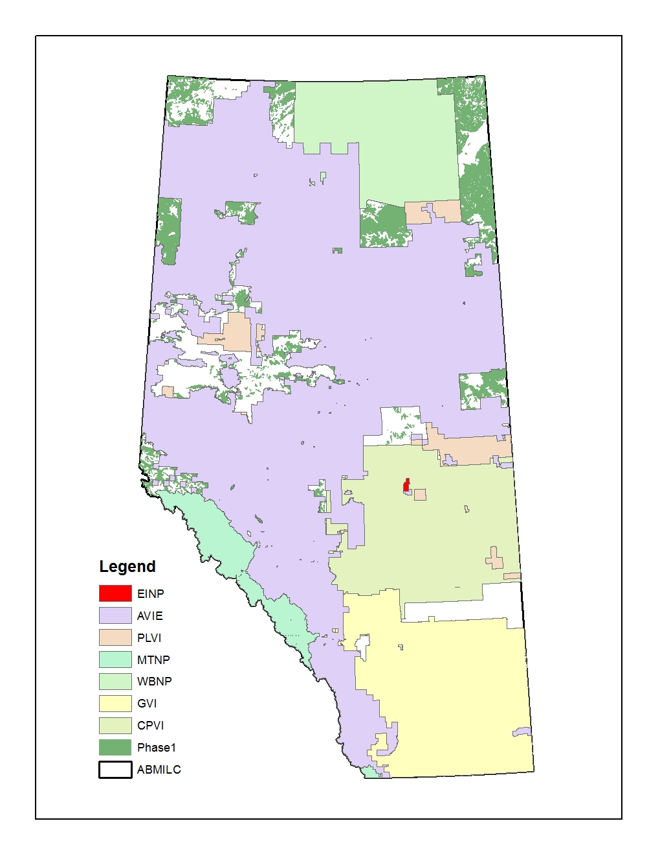
Figure 1 Extent of Major Source Layers.

Wetland Layers
The source layers for wetlands were: Government of Alberta Base Layers for hydropolys and streamlines, Alberta Canadian Wetland Classification System (CWCS) Merged Wetland Inventory, AVIE, PLVI, and GVI layer.

Date of Origin (Stand Age) Layers
The source layers for stand age were: AVIE, PLVI, Provincial Historical Wildfire Data Layer, and the ABMI 2012 Human Footprint Layer.

Soil Type (Ecosite) Layers
The source layers for Soil Type were: GVI_sitetypes_layers (see Section 6.4) and Agriculture Region of Alberta Soil inventory Database (AGRASID).

ABMI 2012 Human Footprint Sub-layers
Human footprint refers to the areas of Alberta that have lost their natural vegetation cover (permanently or temporarily) due to human activities (e.g., cities, roads, agricultural land, industrial areas, forestry, seismic lines, or surface mining). The ABMI has created a GIS polygon layer that contains all human footprints in Alberta up to December 31, 2012. This layer was assembled from 21 human footprint sub-layers. Each sub layer represents one single human footprint type or a group of human footprint types. These 21 human foot print sub-layers were a) used during the backfilling processes described in Section 5, and b) were combined into 8 layers and each of the 8 layers was “stamped” onto the backfilled layer such that human footprint codes and cutblock years were added to the attribute table (see Section 8) where appropriate.

Creation of Backfilled Layer
To create the backfilled layer, the GIS data from various source layers was modified to:
  - Replace (or ‘backfill’) the vegetation classified as “Shrub”, “Grass/Herb” or any other types in cutblocks with the expected pre-disturbance vegetation type (i.e., the forest type expected to be present prior to harvest).
  - Replace linear features (e.g., roads, rail line, pipelines, transmission lines, seismic lines, etc.) with the vegetation type that was adjacent to them.
  - Replace human developed polygons (e.g., cities, mines, industrial sites, agriculture, etc.) with the vegetation type that was expected to be present prior to disturbance.
  - Improve the overall quality of water polygons.
  - Add supplementary information to the backfilled layer’s attribute table, including:
    - Wetland Types (WET) and moisture regime (MOIST_REG),
    - Percentage of pine (PCT_P),
    - Polygon year of origin and origin types (ORIGIN_YEAR, ORIGIN_TYPE), and
    - Soil type for Grassland and Parkland Natural Regions and Dry Mixedwood Natural Subregion (SOIL_TYPE)

The backfilled layer containing the supplemental information is referred to as the ‘Alberta Backfilled Wall-to-Wall Vegetation Layer (Version 5)’. The following sections describe in detail the various procedures and sources of information used in the creation of this layer.

Removal of Human Footprint (‘Backfilling’)

Extended Alberta Vegetation Inventory (AVIE) layer

Natural vegetation identification and classification for AVIE layer

The Extended AVI layer (AVIE) provided by AESRD in January of 2014 was used, and the following three GIS operations were applied to exclude the human-disturbed polygons:

- Anthropogenic vegetated polygons were excluded by selecting polygons where “ANTH_VEG” was blank. This rule had the effect of excluding polygons described as industrial (‘CIP’ and ‘CIW’) or agricultural (‘CA’, ‘CP’, and ‘CPR’).
- Anthropogenic non-vegetated polygons were excluded by selecting polygons where “ANTH_NON” was blank. This rule had the effect of excluding polygons described as settlement areas (‘ASC’ and ‘ASR’) or industrial development (‘AIE’, ‘AIF’, ‘AIG’, ‘AIH’, ‘AII’, and ‘AIM’).
- Human disturbed forest polygons were excluded by selecting polygons where MOD1 or MOD2 was not equal to clearcut (‘CC’), clearings (‘CL’), site improved (‘SI’), scarification (‘SC’), planted or seeded (‘PL’), and thinned (‘TH’).

Naturally disturbed types in AVIE were also excluded by selecting polygons where “NAT_NON” was not equal to Flooded (‘NWF’), Cutbank(‘NMC’), and Recent Burn (‘NMB’).

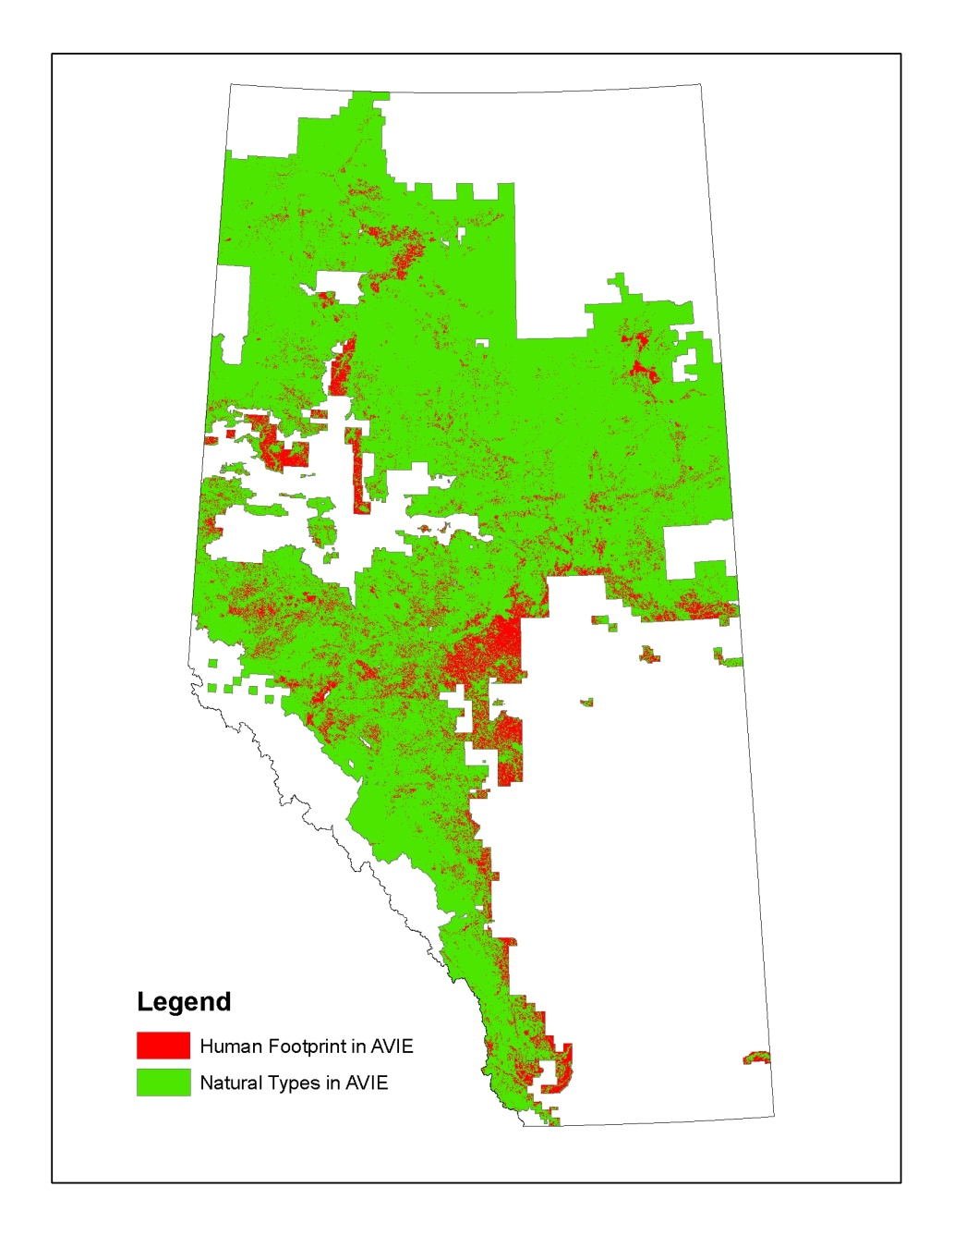
Figure 2 Extent of the Extended Alberta Vegetation Inventory layer showing natural vegetation types and human footprint for backfilling.

The vegetation types included in the backfilled layer were derived from the AVIE layer according to the rule-set in Table 1. A python script was developed and is available upon request.

Table 1 Definition of vegetation types derived from the AVIE.
Vegetation Type | Description
Pine | Stands where the combined pine (P, Pl, Pa, Pj, Pf) are the leading species in stand, and deciduous species comprise ≤ 20%
Black spruce | Stands where black spruce is the leading species in stand, and deciduous species comprise ≤ 20%
White spruce | Stands where the combined White Spruce (Sw) and Engelmann spruce (Se) are the leading species in stand, and deciduous species comprise ≤ 20%
Fir | Stands where the combined Fir (Fa, Fb, Fd) are leading species in stand, and deciduous species comprise ≤ 20%
Larch | Stands where the combined Larch (Lt, La, Lw) are leading species in stand, and deciduous species comprise ≤ 20%
Deciduous | Stand where the combined deciduous species ≥80%
Mixedwood | Stands where the combined deciduous species >20%, and combined conifer species > 20%
Shrub | Non-Forested Land (NFL) Classifier = Open Shrub (SO) or Closed Shrub (SC)
Grass/Herb | Non-Forested (NFL) Classifier = Herbaceous Grassland (HG), Herbaceous Forbs (HF), or Bryophytes /Lichens (BR)
IceSnow | Naturally Non-Vegetated (NAT_NON) Classifier is Permanent ice/snow (NWI)
Rock/Rubble | Naturally Non-Vegetated (NAT_NON) Classifier is Rock barren (NMR)
Sand | Naturally Non-Vegetated (NAT_NON) Classifier is Sand (NMS)
Water | Naturally Non-Vegetated (NAT_NON) Classifier is River (NWR) or Lake (NWL). Note, Water is not used for backfilling.

Origin Year and Origin Type from AVIE

The origin year of each polygon was defined from the fields ORIGIN, MOD1_YR, MOD2_YR, UMOD1_YR, or UMOD2_YR. This origin year was used for backfilling the AVIE layer. It was also used in the “ORIGIN_TYPE” and “ORIGIN_YEAR” fields, where the provincial fire layer was incorporated (See Section 6.3). In single layered stand, the ORIGIN field was replaced by MOD1_YR or MOD2_YR if the extent (field MOD1_EXT or MOD2_EXT) indicated the loss of crown closure was ≥ 76% (i.e., values of 4 or 5), and the type (field MOD1 or MOD2) indicated a burn (‘BU’), windfall (’WF’) or insect kill (‘IK’). If both MOD1 and MOD2 met the criteria, the most recent year was used for the ORIGIN_YEAR. For the horizontal stand and multilayer stand where the understory was the dominant layer, UMOD1_YR or UMOD2_YR were used with the same rule-set as above.

Backfilling AVIE layer

The human-disturbed polygons (i.e., human footprint, shown in red in Figure 2) were divided into four groups: linear, cutblock, peat, and others, with each group backfilled according to a group-specific set of procedures and rule sets (Table 2).

Table 2 Backfilling rules for four human footprint types from the AVIE.
Human Footprint Type | Backfilling Rules
Cutblock | Only old upland forest types, i.e. Pine, White spruce, Fir, Deciduous, Mixedwood with origin year less than 1930, were assigned.
Peat | Only lowland vegetation types, i.e. Black Spruce, Larch, and Shrubland, were assigned. Moisture was assumed to be wet.
Linear Human Footprint | Any Vegetation Types could be assigned.
Others | Any Vegetation Types could be assigned.
The backfilling rules for the 3 naturally disturbed types in AVIE were defined as follow. Flooded (NWF) was backfilled with non-treed types only. Cutbank was backfilled with treed types only. Recent Burn (NMB) was backfilled as “Shrub”.

Linear Human Footprint
Linear polygons were identified by selecting: 1) Permanent rights of way; roads, highways, railroads, dam sites, reservoirs (“ANTH_NON” or “UANTH_NON” = ‘AIH’), or 2) Pipelines, transmission lines, airstrips, microwave tower sites that have been seeded to perennial grasses (“ANTH_VEG” or “UANTH_VEG”= ‘CIP’).

Cutblocks
Cutblock polygons were derived by clipping the original AVIE layer (both Red and Green shown in Figure 2) with the cutblock polygons in the 2012 human footprint layer. Using the cutlbock polygons in the 2012 human footprint layer as the template ensures old forest types underneath all the cutblocks in the final layer.

Polygons which were identified as Cutblock by AVIE, i.e., MOD1 or MOD2 was equal to clearcut (‘CC’), clearings (‘CL’), site improved (‘SI’), scarification (‘SC’), planted or seeded (‘PL’), and thinned (‘TH’), but fall outside of the 2012 cutblock template were backfilled with the rules in the “Others” group.

Peat
Peat polygons were selected where “ANTH_NON” = ‘AIE’.

Backfilling Process
A “multipart to Singlepart” GIS operation was run first to make sure each polygon had a single unique corresponding record in the attribute table. Two natural vegetation layers were also created. One was derived from Phase 1 Alberta Vegetation Inventory layer (Phase 1) (also known as the Broad Inventory layer, originally produced as a hardcopy map in 1957). The other was derived from ABMI Alberta Wall-to-Wall Land Cover Polygon vector layer (ABMILC).

The derived natural vegetation layer from Phase 1 had five vegetation types (i.e., Coniferous, Deciduous, Mixedwood, MuskegMarsh and RockBarren; see Figure 3 and Table 3).
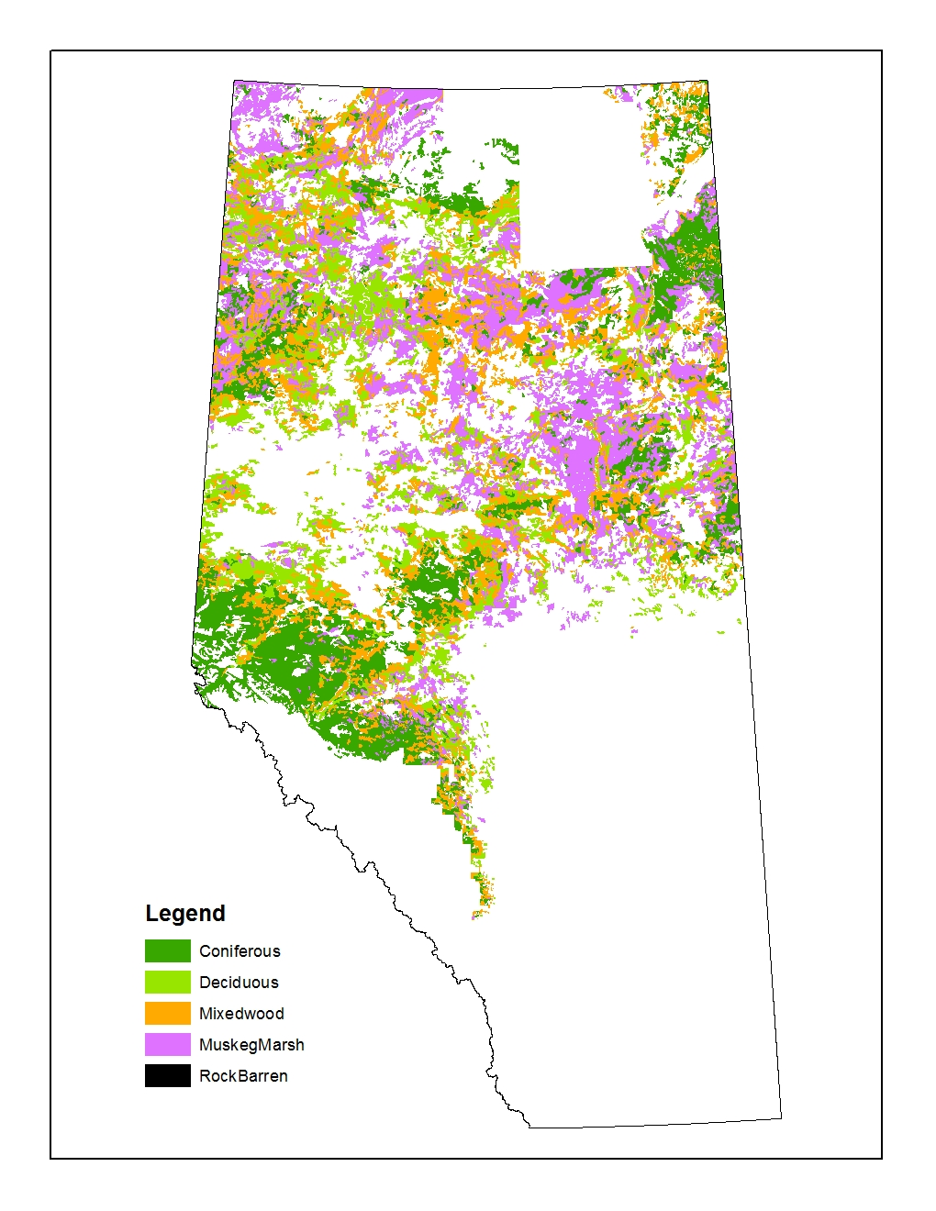
Figure 3 Natural vegetation types derived from the AVI Phase I layer. The definitions for each type are given in Table 3.

Table 3 Phase I layer classes and merging rules for the natural vegetation types.
Phase 1 Class | Description | Vegetation Types
10 | Agriculture and other improved lands
14 | Barren above timberline
7 | Burns - 1941 to 1957 inclusive
2 | Coniferous stands over 60’ height | Coniferious
1 | Coniferous stands up to 60' height | Coniferious
6 | Deciduous stands over 60' height | Deciduous
5 | Deciduous stands up to 60' height | Deciduous
15 | Indian Reserves
16 | Lakes and Rivers
4 | Mixedwood stands over 60' height | Mixedwood
3 | Mixedwood stands up to 60' height | Mixedwood
11 | Muskeg and Marsh | MuskegMarsh
17 | National Park
9 | Old burn - productive and non-productive
8 | Old burn and brushland
12 | Rock barren | RockBarren
The derived natural vegetation layer from ABMILC had seven vegetation types (i.e., Coniferous forest, Broadleaf forest, Mixed forest, Shrubland, Grassland, Rock/Rubble, and Snow/Ice; see Figure 4 and Table 4). All natural vegetation polygons falling in the ABMI HF 2012 were also removed.

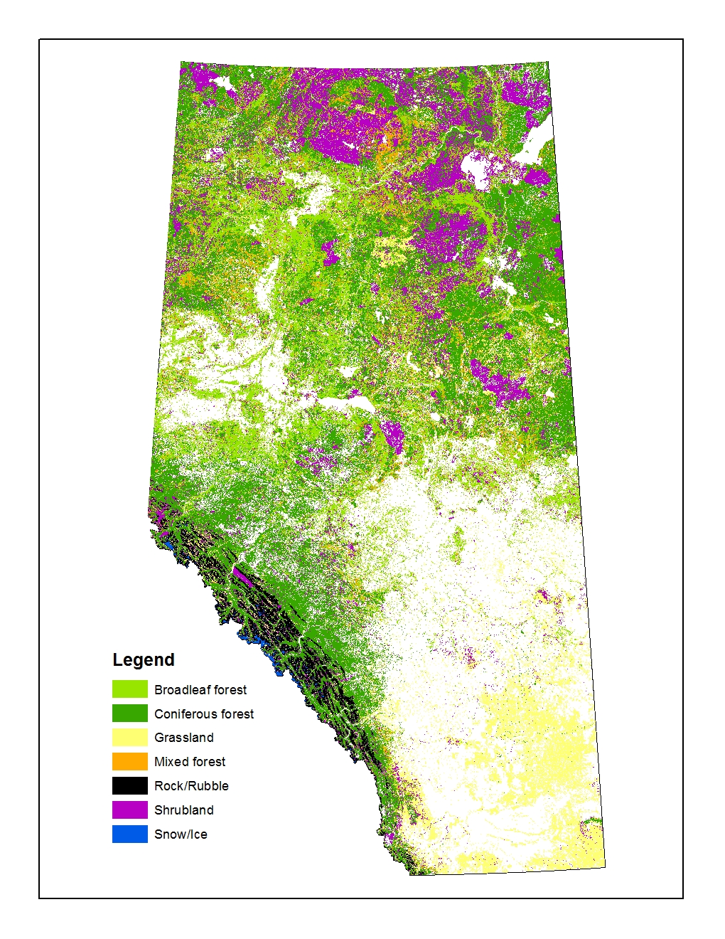
Figure 4 Natural vegetation types derived from the ABMILC layer.

Table 4 ABMILC layer classes and the derived natural vegetation types.
LC | LcType | Natural Vegetation Types
20 | Water
31 | Snow/Ice | Snow/Ice
32 | Rock/Rubble | Rock/Rubble
33 | Exposed land
34 | Developed
50 | Shrubland | Shrubland
110 | Grassland | Grassland
120 | Agriculture
210 | Coniferous forest | Coniferous forest
220 | Broadleaf forest | Broadleaf forest
230 | Mixed forest | Mixed forest

Backfilling cutblock polygons in AVIE:
In general, if the cutblock polygon had a harvestable forest class within 50m of the cutblock boundary, it was backfilled with the dominant forest class in the neighbouring 50m buffer. Otherwise, it was backfilled with the information from other layers (See Figure 5 for details). Old upland forest types (i.e., Pine, White spruce, Fir, Deciduous, Mixedwood with origin year prior to 1930) and age and moisture info were backfilled to the cutblocks from the AVIE natural vegetation layer. The general vegetation types (i.e, coniferous, deciduous, mixedwood and pine) were backfilled to the cutblocks from the other natural vegetation layers. Large polygons (> 500 ha) were first cut into smaller polygons with the ArcGIS dice tool before backfilling.

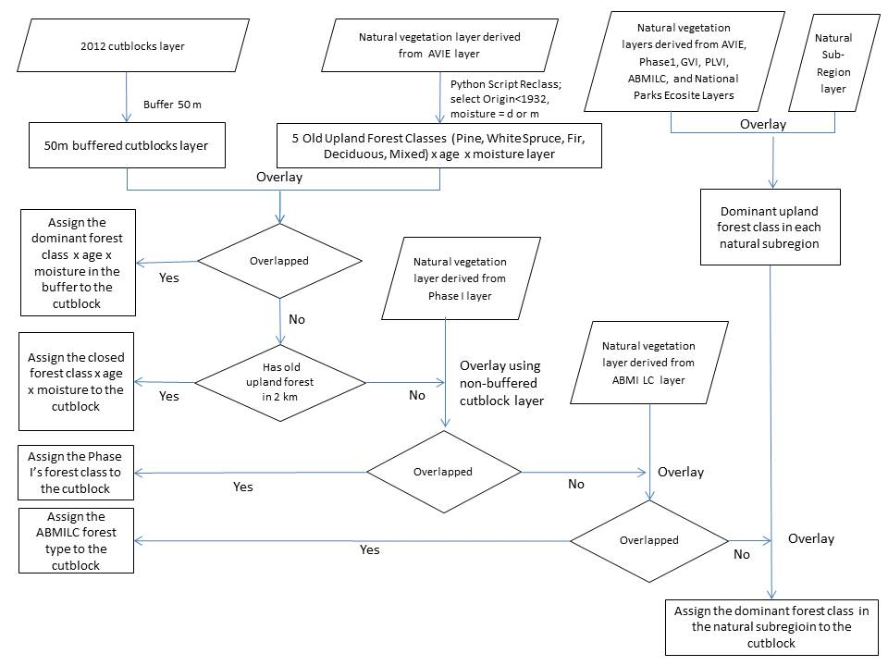
Figure 5 Flow chart illustrating the rule set used in backfilling polygons in AVIE identified as forest harvest operations with pre-harvest vegetation conditions.

The dominant upland forest type and vegetation type derived from all the source layers in each natural sub-region are shown in Table 5.

Table 5 Dominant vegetation type and upland forest type in each natural sub-region (NSRNAME) used for backfilling cutblocks and other human footprint types.

NSRName | Vegetation Type | Upland Forest Type
Alpine | Grass/Herb | Coniferous
Athabasca Plain | Pine | Pine
Boreal Subarctic | Shrub | Coniferous
Central Mixedwood | Deciduous | Deciduous
Central Parkland | Deciduous | Deciduous
Dry Mixedgrass | Grass/Herb | Coniferous
Dry Mixedwood | Deciduous | Deciduous
Foothills Fescue | Grass/Herb | Deciduous
Foothills Parkland | Deciduous | Deciduous
Kazan Uplands | Pine | Pine
Lower Boreal Highlands | Black Spruce | Deciduous
Lower Foothills | Coniferous | Coniferous
Mixedgrass | Grass/Herb | Deciduous
Montane | Coniferous | Coniferous
Northern Fescue | Grass/Herb | Deciduous
Northern Mixedwood | Black Spruce | Deciduous
Peace River Parkland | Shrub | Deciduous
Peace-Athabasca Delta | Grass/Herb | Deciduous

The human disturbed forest polygons that fell outside of Cutblock 2012 template layer were considered as errors. These polygons, i.e., MOD1 or MOD2 equal to clearcut (‘CC’), clearings (‘CL’), site improved (‘SI’), scarification (‘SC’), planted or seeded (‘PL’), and thinned (‘TH’), were backfilled with its own vegetation types if existed. Otherwise, they were backfilled with the same rule-set as the “Others” group in Table 2.

Backfilling other human disturbed polygons excluding cutblocks, peat and linear types
The procedures for backfilling other human disturbed polygons excluding cutblocks, peat extraction sites and linear features (“Others” in Table 2) followed similar steps (Figure 6) to those used for cutblocks (Figure 5) with the exception that 1) vegetation type was not constrained to old upland forests (Error! Reference source not found.), and 2) only small polygons (A<10 ha) were first backfilled with AVIE.

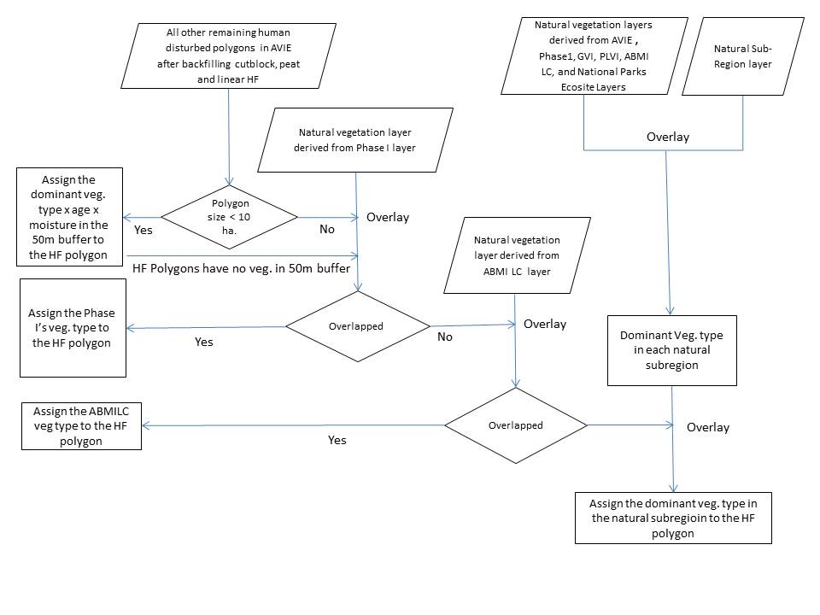
Figure 6 Flow chart illustrating the rule set used in backfilling other human disturbed polygons excluding cutblock, peat and linear types in AVIE.
.

The dominant vegetation types in each natural sub-region are shown in Table 5.

Backfilling peat polygons in AVIE
The peat polygons were backfilled with black spruce, larch, or shrub vegetation types according to the procedure described in Figure 7.
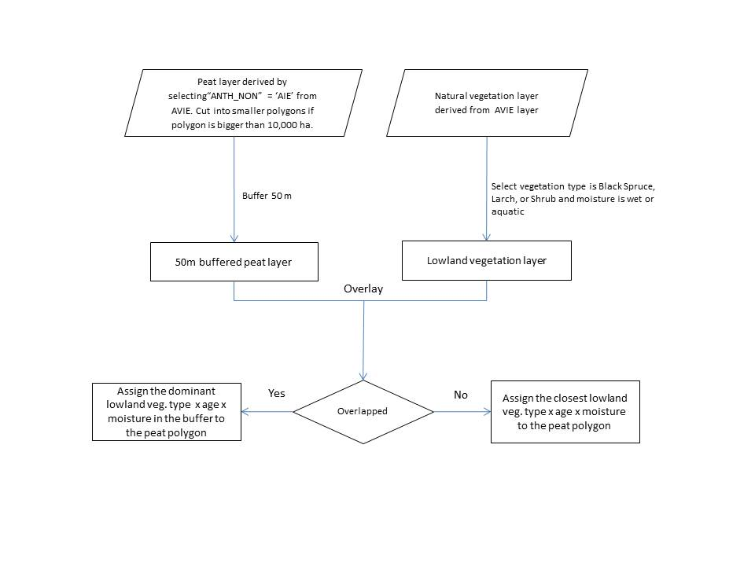
Figure 7 Flow chart illustrating the rule set used in backfilling peat polygons in AVIE.

Backfilling linear types in AVIE
The linear human-disturbed vegetation types were backfilled using the neighbouring vegetation type, age and moisture information. The linear polygons are first cut into smaller segments with the “Dice” tool in ArcMap. The neighboring natural vegetation layer was assembled from the natural vegetation layer derived from AVIE, the backfilled cutblocks, the backfilled peat, and the backfilled other human disturbed polygons described above. The “eliminate” tool in ArcGIS was repeatedly used until no human-disturbed linear features remained that could be backfilled.

New water boundaries for backfilled AVIE layer
The open water polygons from AVIE, River (NWR) and Lake (NWL), were combined with more detailed polygons obtained from the Government of Alberta Base Layers for hydropoly and stream lines. This open water polygon layer was stamped onto the backfilled AVIE layer. All open water polygons from the original AVIE layer that fell outside of the new open water boundaries (i.e., from the Government of Alberta Base Layer Database) were still kept as water since AVI interpretation of water was also thought to be accurate.

The hydropoly sub-layer in the more detailed water polygon layer contained polygons of multiple feature types (see Table 6), not all of which were relevant to updating open water boundaries. Therefore, feature types indicating islands ('ISLAND-LAKE', 'ISLAND-RECUR', and 'ISLAND-RIV') and wetlands (‘WETLAND’) were not classified as open water.

The stream line sub-layer in the more detailed water polygon layer was buffered according to Table 7.

Table 6 List of feature types (FEATURE_TY) contained within the Government of Alberta hydropoly layer, and whether they were used to update the boundaries of open water areas in the backfilled layer.

Feature Type | Used to Update Open Water Boundaries?
CANAL-MAJ | Yes
DUGOUT | Yes
ICEFIELD | Yes
ISLAND-LAKE | No
ISLAND-RECUR | No
ISLAND-RIV | No
LAGOON | Yes
LAKE-PER | Yes
LAKE-RECUR | Yes
OXBOW-PER | Yes
OXBOW-RECUR | Yes
QUARRY | Yes
RESERVOIR | Yes
RIV-MAJ | Yes
WETLAND | No

Table 7 Buffer sizes (m) used in the stream line layer added to the backfilled layer to improve the accuracy of open water boundaries.

Feature Type | Buffer size to each side (m)
AQUEDUCT | 1
CANAL | 1
DITCH | 1
ICEFIELD-REP-PRI | 1
OXBOW-RECUR | 1
STR-RECUR | 1
CANAL-MAJ-REP-SEC | 2
OXBOW-PER | 2
RIV-MAJ-REP-SEC | 2
SPILLWAY | 2
CANAL-MAJ-REP-PRI | 3
LAKE-REP-PRI | 3
RIV-MAJ-REP-PRI | 3
FLOW-ARB-DEM | Excluded
FLOW-ARB-MANUAL | Excluded
STR-INDEF | 0.5
STR-PER | 1.5

Post cleaning up backfilled AVIE layer
Polygons with area less than 100 square meters were backfilled with the same information as its neighbor polygon.

Primary Land and Vegetation Inventory (PLVI) layer

Natural vegetation identification and classification for PLVI layer

The natural vegetation polygons in the PLVI layer (Figure 8) were identified by selecting polygons in which the field “Land Class 1” indicated the land cover was Naturally Wooded (NAW), Wetland (WET), or Naturally Non-wooded (NNW).

The Vegetation Types were generated according to the rule-set in Table 8. A python script was developed and is available upon request.

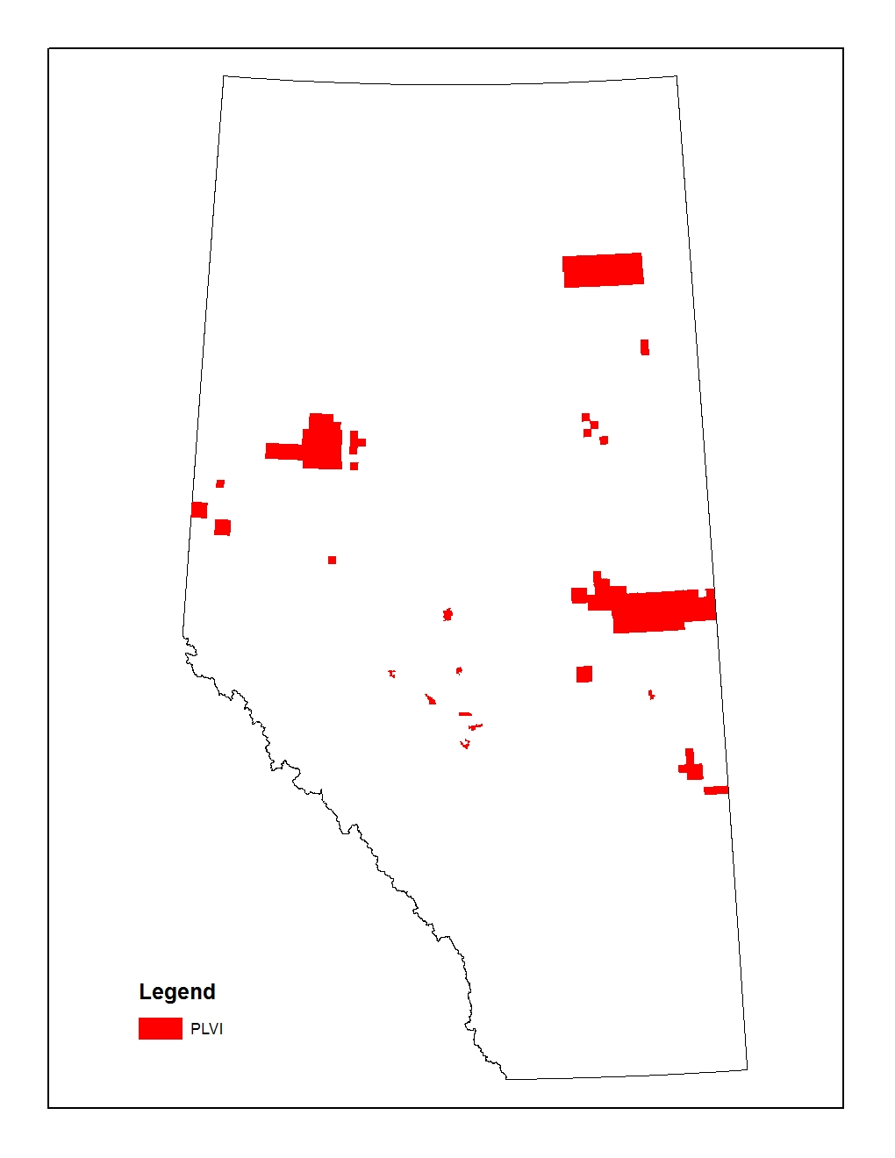
Figure 8 Extent of the Primary Land and Vegetation Inventory (PLVI).

Table 8 Definitions of the vegetation types derived from the Primary Land and Vegetation Inventory (PLVI).

Vegetation Type | Description
Pine | Coniferous Percent 1 > 80% and Leading Species 1 in (P, Pl, Pa, Pj, Pf) and Site Type 1 are forested (FT), Treed wetland (WT) or Treed Fens (TF)
Black spruce | Coniferous Percent 1 > 80% and Leading Species 1 is Black Spruce (Sb) and Site Type 1 are forested (FT), Treed wetland (WT) or Treed Fens (TF)
White spruce | Coniferous Percent 1 > 80% and Leading Species 1 is White Spruce (Sw) and Site Type 1 are forested (FT), Treed wetland (WT) or Treed Fens (TF)
Fir | Coniferous Percent 1 > 80% and Leading Species 1 in (Fa, Fb, Fd) and Site Type 1 are forested (FT), Treed wetland (WT) or Treed Fens (TF)
Larch | Coniferous Percent 1 > 80% and Leading Species 1 in (Lt, La, Lw) and Site Type 1 are forested (FT), Treed wetland (WT) or Treed Fens (TF)
Deciduous | Coniferous Percent 1 ≤ 20% and Site Type 1 are forested (FT), Treed wetland (WT) or Treed Fens (TF)
Mixedwood | Coniferous Percent 1 > 20% and ≤ 80%, and Site Type 1 are forested (FT), Treed wetland (WT) or Treed Fens (TF)
Shrub | Site Type 1 are Shrub Bog (WS), Shrub Fens (SF), Open Shrub (OS), Medial Shrub (MS), or Closed Shrub (CS)
Grass/Herb | Site Type 1 are Grass Fens (GF), or Herbaceous Grass (HG)
Marsh | Site Type 1 is Marsh (M). Note, this type is not used for backfilling.
Swamp | Site Type 1 is Swamp (SW). Note, this type is not used for backfilling.
Rock | Site Type 1 is Rock (NMR).
Sand | Site Type 1 is Sand (NMS).
Ice | Site Type 1 is Ice (NMI).
Water | Site Type 1 is Water (NW) and SitePct1 >=8. Note, Water is not used for backfilling.

The Origin Year was derived from the fields Disturbance Year 1, Pioneering Succession Stage 1, and Serial Succession Stage 1. If the field “Disturbance Percent 1” was ≥ 80%, the Origin Year was copied from the field “Disturbance Year 1”. The Origin Years for the remaining polygons were then generated from the field “Pioneering Succession Stage 1”, or the field “Seral Succession Stage 1”, according to the rules in Table 9 and Table 10.

Table 9 Forest age derived from pioneering tree species successional stage in PLVI.

Successional Stage | ORIGIN YEAR
Stand Initiation (SI) | 5 years before image year. If no image year, 2010 was used.
Stem Exclusion (SE) | 25 years before image year. If no image year, 2010 was used.
Mature (MA) | 70 years before image year. If no image year, 2010 was used.
Breakup (BP) | 150 years before image year. If no image year, 2010 was used.
No pioneer (XP) | Not Applicable

Table 10 Forest age derived from serial tree species succession stage in PLVI.

Successional Stage | ORIGIN YEAR
Recruitment (RC) | 5 years before image year. If no image year, 2010 was used.
Intermediate (IM) | 25 years before image year. If no image year, 2010 was used.
Mature (MT) | 70 years before image year. If no image year, 2010 was used.
Climax (CM) | 150 years before image year. If no image year, 2010 was used.
No seral (XS) | Not Applicable

The MOIST_REG field was copied from the field “Map Code 1”. In PLVI, the map codes were used by the photo interpreter to describe ecological sites, which has both Moisture Regime (2 – Xeric, 3 – Subxeric, 4 – Submesic , 5 –Meisc, 6 – Subhygric, 7 – Hygric, 8 – Subhydric, and 9 - Hydric) and Nutrient Regime (A - Very Poor, B - Poor , C – Med. , D - Rich, and E –Very rich). For more information on Map Codes, refer to the PLVI metadata documents.

Backfilling the PLVI layer

The following procedures only apply to PLVI in the Parkland and Boreal natural region. No backfilling was done for the PLVI layer in the Grassland region. In the current version of PLVI, no polygons are in the Grassland region.

The human-disturbed polygons in the PLVI layer were first backfilled using data from its own attribute table if the fields “Site Type 2” or “Site Type 3” indicated natural vegetation types. This approach was based on the assumption that the information from that attribute table was a better approximation of natural vegetation types than information from neighboring polygons.

Attribute table fields with names ending with “2” (i.e., “Coniferous Percent 2”, “Leading Species 2”, and “Site Type 2”) were first used to generate the natural vegetation types by applying the rule set provided in Table 8 with the additional constraints list in Table 11. Attribute table fields with names ending as 3 (i.e., “Coniferous Percent 3”, “Leading Species 3”, and “Site Type 3”) were used subsequently for the remaining un-backfilled polygons by following the same procedure. The Origin Year and moisture fields were also backfilled with the same procedure.

Table 11 Constraints for backfilling human disturbed polygons with their own attribute data in the Primary Land and Vegetation Inventory (PLVI) layer

Human Footprint Group | Site Type 1 | Valid vegetation Types from Coniferous Percent 2”, “Leading Species 2”, and “Site Type 2”
Cutblock | Recent Harvest (CC), Regeneration (CR) | Only Pine, White spruce, Fir, Mixedwood, and Deciduous
Linear Human Footprint | Transportation Surface (AIH), Non-treed Clearings (CIP), Treed Clearings (CIT) | No backfilling with its own fields
Others | Annual Crops (CA), Tame Pasture (CP), Rough Pasture (  CPR), Settlement Tracts (ASC), Industrial Tracts (AII) | Any vegetation types

The remaining un-backfilled human disturbed polygons, after backfilled from its own fields in the attribute table, were divided into 3 groups: cutblock, linear and others. The grouping rules followed those in Table 11, except for cutblocks which were identified by clipping with the 2012 cutblock polygons in the 2012 Human Footprint Layer.

Each of the three groups above (cutblock, linear, and other) were backfilled with the same procedures as for backfilling the AVIE layer (See Section 5.1.3).

Water boundaries for the backfilled PLVI layer

The open water polygons in the PLVI layer, i.e., Site Type 1 is Water (NW) and SitePct1 >=8, were combined with more detailed polygons obtained from the Government of Alberta Base Layers for hydropoly and stream lines. See detailed information for this open water polygon layer at Table 6 and Table 7 in Section 5.1.4. This open water polygon layer was stamped onto the backfilled PLVI layer. All open water polygons from the original PLVI layer that fell outside of the new open water boundaries (i.e., from the Government of Alberta Base Layer Database) were still kept as water were retained since the PLVI mapping was assumed to be accurate.

Post cleaning up backfilled PLVI layer
Polygons with areas <100 m² were backfilled with the same information as its neighbouring polygon.

Grassland Vegetation Inventory Layer (GVI)

Extended GVI layer

The GVI layer contained polygon data for southern Alberta (Figure 9). Detailed information for each polygon was not stored in the attribute table of the GVI “LANDSCAPE_POLYGON” layer. Therefore, to assist with vegetation classification and backfilling, the GVI “LANDSCAPE_POLYGON” layer was extended by adding several fields (Table 12) to the attribute table. These 19 additional fields were derived either from the GVI tables “SITES” and “VEGETATION”, or the GVI “View_Rangeland” layer. The definitions of these new fields and the processing steps were described below and in Table 12.
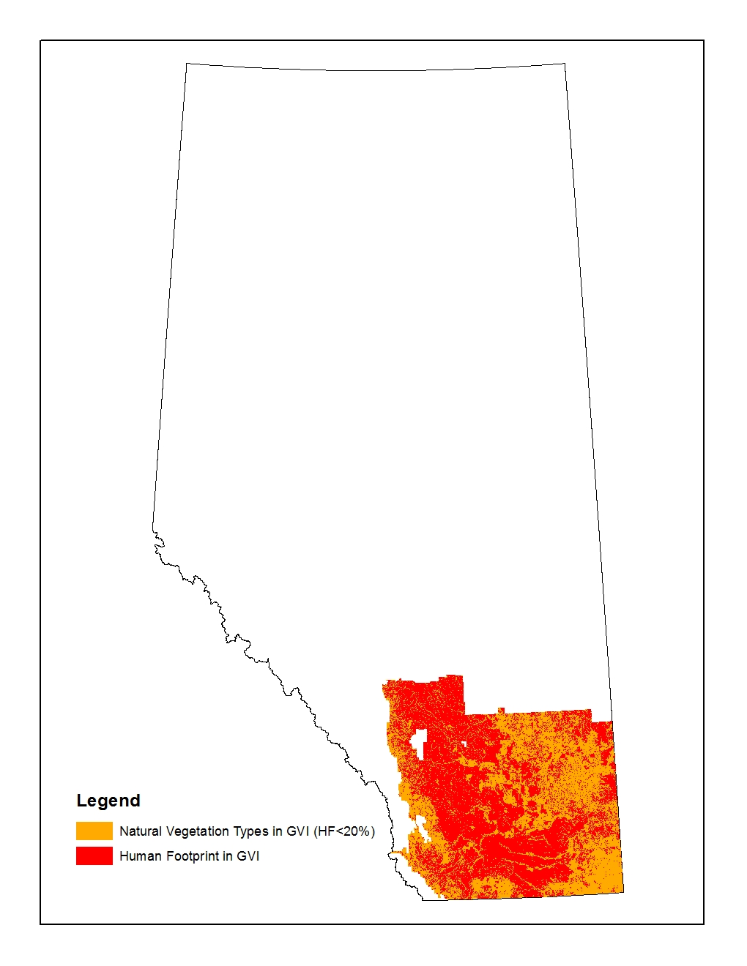
Figure 9 Extent of the Grassland Vegetation Inventory (GVI) in Alberta showing natural vegetation types and human footprint for backfilling.

A “LinkID” field was added to the attribute table of GVI “LANDSCAPE_POLYGON” layer and a unique ID number was assigned to each of the GVI polygons. This “LinkID” was used as a table key to link various derived intermediate tables during processing in Microsoft Access. The “GLOBALID” field in the table was used only to link the “LANDSCAPE_POLYGON” layer with the GVI “View_Rangeland” layer and “SITES” and “VEGETATION” tables in the GVI file geo-database.
Table 12 Fields added to the attribute table of the Grassland Vegetation Inventory (GVI) “LANDSCAPE_POLYGON” layer

Field Name | Description
PctTrees | Percentage of trees coverage in the polygon. Note, The sum of PctTrees, PctShrubs, PctGrass, PctNonVeg and PctWater equals to 100.
PctShrubs | Percentage of shrub coverage in the polygon.
PctGrass | Percentage of grass coverage in the polygon.
PctNonVeg | Percentage of non-vegetation coverage in the polygon.
PctWater | Percentage of water coverage in the polygon.
SumOfEachTreePct | The sum up of the next 7 columns. The value should be 100 or 0 (This field is used for Quality Assurance only)
BlackSpruce | Percentage of total trees areal coverage that was black spruce.
Coniferous | Percentage of total trees areal coverage that was coniferous trees.
Dec | Percentage of total trees areal coverage that was deciduous trees.
Fir | Percentage of total trees areal coverage that was fir.
Larch | Percentage of total trees areal coverage that was larch.
Pine | Percentage of total trees areal coverage that was pine.
WhiteSpruce | Percentage of total trees areal coverage that was white spruce.
ABMIWet | Percentage of ABMI wetland site types coverage in the polygon. The ABMI wetland site types include LenS, LenSP, LtcS, and LtcH (See Table 14 for ABMI Moisture regime)
LtcRLenWPct | Percentage of site types LtcR and LenW coverage in the polygon.
LtcCDPct | Percentage of site types LtcC and LtcD coverage in the polygon.
LtcSHPct | Percentage of site types LtcS and LtcH coverage in the polygon.
HFPct | Percentage of Human Footprint coverage in the polygon.
DomNatSiteType | Dominant Natural site type which had maximum coverage.

The fields BlackSpruce, Coniferous, Dec, Fir, Larch, Pine, and WhiteSpruce were derived from the VEGETATION table and SITES table using the following three steps:
- First, each row (i.e., one species) of the vegetation table was assigned to one of seven tree types (BlackSpruce, Coniferous, Dec, Fir, Larch, Pine, and WhiteSpruce) according to the SPECIES_ID field.
- Second, the percentage of this species in the GVI polygon was then calculated with the equation (“PCT_OF_CLASS” in the VEGATATION table × “PCT_TREES” in the SITES table × “PCT_OF_Polygon” in the SITES table) / the newly added “PctOfTrees”.
- Finally, the percentage of each tree types on the GVI polygon was derived with a crosstab operation by summing up the percentage of each species (row) on the polygon.
For the dominant natural site type field (Field DomNatSiteType), when there was more than one natural site type with the same maximum coverage, the dominant type was determined manually by an expert with the aid of the ABMI Soil Types layer (See Section 6.4 for this layer).

Natural vegetation identification and classification for GVI layer

The natural vegetation types in the GVI layer were derived according to the rule set in Table 13. The rule of “greater than 60% of wet area” was used to assign the wetland types (Swamp, Marsh, Alkali, Lotic Shrub, and Lotic Herb). A python script was developed and is available upon request.

Table 13 Definition of Vegetation Types derived from the Grassland Vegetation Inventory (GVI)
Vegetation Type | Description
Pine | PctTree >= 20 and Dec_ < 20 and Pine > BlackSpruce, WhiteSprice, Fir and Larch.
Black spruce | PctTree >= 20 and Dec_ < 20 and BlackSpruce > Pine, WhiteSprice, Fir and Larch.
White spruce | PctTree >= 20 and Dec_ < 20 and WhiteSpruce > BlackSpruce, Pine, Fir and Larch.
Fir | PctTree >= 20 and Dec_ < 20 and Fir > BlackSpruce, WhiteSprice, Pine and Larch.
Larch | PctTree >= 20 and Dec_ < 20 and Larch > BlackSpruce, WhiteSprice, Fir and Pine.
Deciduous | PctTree >= 20 and Dec_ >80
Mixedwood | PctTree >= 20 and Dec_<=80 and >= 20.
Coniferous | PctTree >= 20 and Dec_ < 20
Shrub | PctTree < 20 and PctShrub >= 20
Grass/Herb | PctTree < 20 and PctShrub < 20 and PctNonVeg <80
Bareland | PctTree < 20 and PctShrub < 20 and PctNonVeg>= 80
Swamp | PctTree >= 20 and PctABMIwet+PctLtcRLenW>=60
Marsh | PctTree < 20 and PctABMIwet+PctLtcRLenW>=60
Alkali | PctTree < 20 and PctABMIwet+PctLtcRLenW>=60 and DomSiteType =LenA
Lotic Shrub | PctTree < 20 and and PctShrub >= 20 and PctABMIwet+PctLtcRLenW>=60 and DomSiteType =LtcS
Lotic Herb | PctTree < 20 and and PctShrub < 20 and PctABMIwet+PctLtcRLenW>=60 and DomSiteType =LtcH

Data for the MOIST_REG field was derived from dominant natural site type (Field DomNatSiteType). A conversion rule was developed to convert the dominant natural site type into the ABMI moist regime (Table 14).

Table 14 Conversion from the Grassland Vegetation Inventory (GVI) Site Type to the ABMI moisture regime
GVI Site Type | GVI Code | GVI ID | ABMI Moisture Regime
Lentic - Temporary | LenT | 1 | Mesic
Lentic - Seasonal | LenS | 2 | wet
Lentic - Alkali | LenA | 3 | wet
Lentic - Semi to Permanent | LenSP | 4 | wet
Lentic - Open water | LenW | 5 | Open water
Lotic - River | LtcR | 6 | Open water
Lotic - Coniferous | LtcC | 7 | Mesic
Lotic - Deciduous | LtcD | 8 | Mesic
Lotic - Shrub | LtcS | 9 | wet
Lotic - Herbaceous | LtcH | 10 | wet
Subirrigated | Sb | 11 | Mesic
Overflow | Ov | 12 | Mesic
Clayey | Cy | 13 | Mesic
Loamy | Lo | 14 | Mesic
Sandy | Sy | 15 | dry
Limy | Li | 16 | Mesic
Sandy | Sa | 17 | dry
Blowouts/Solonetzic | BlO | 18 | dry
Choppy Sandhills | CS | 19 | dry
Thin Breaks | TB | 20 | dry
Shallow to Gravel | SwG | 21 | dry
Saline Lowland | SL | 22 | Mesic
Gravel | Gr | 23 | dry
Badlands /Bedrock | BdL | 24 | dry

Backfilling the GVI layer
The GVI polygons falling in the ABMI 2012 Human Footprint layer were assumed as human footprint. Also, any GVI polygons in which the total percentage of human footprint exceeded 20% were assumed as human footprint. Different backfilling procedures were applied depending on the polygon in or out of ABMI 2012 Human Footprint layer.

The polygons that were located within the bounds of the ABMI 2012 Human Footprint layer were backfilled with the soil layer (see Section 6.4 for detailed information for this layer). The rules described in Table 15.

Table 15 Rule set used to backfill Human Footprint based on soil type.
Natural Region | Rule set
Grassland | Coniferous = LtcC  Deciduous = LtcD, Ltc  Shrub = LenSP, LtcS, Ov, Sb, TB, Len  Grass/Herb = BdL, BlO, CS, Cy, Gr, LenA, LenS, LenT, LenW, Li, Lo, LtcH, LtcR, SL, Sa, SwG, Sy
Parkland | Coniferous = LtcC  Deciduous = BdL, Gr, Li, Lo, LtcD, Ov, Sa, Sb, SwG, Sy, Ltc  Shrub = CS, Cy, LenS, and LenSP, Len, TB  Grass/Herb = BlO, LenA, LenW, LtcR
Dry Mixedwood and Lower Foothills | Coniferous = LtcC  Deciduous= BlO, CS, LtcD, TB  Mixedwood = BdL, Cy, Gr, Li, Lo, LctR, Ov, Sa, Sb, SwG, Sy  Shrub = LenSP, Len  Grass/Herb = LenW

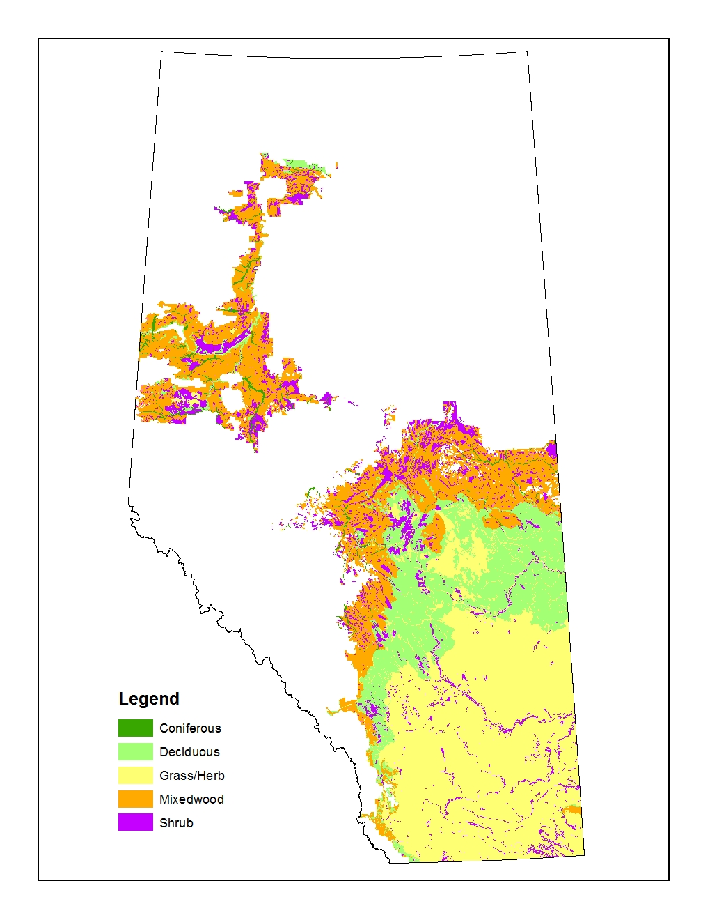
Figure 10 Natural vegetation types derived from the soil type layer.

The human footprint polygons that were located outside the bounds of the ABMI 2012 Human Footprint layer were overwritten (in order of precedence) by ABMILC and the dominant vegetation type in the natural subregion where they overlapped.

New Water Boundaries for the Backfilled GVI layer
The open water polygons were first identified with the rule of Lentic – Open water (LenW) + Lotic – River (LtcR) >=80. The open water polygons in GVI were combined with more detailed polygons obtained from the Government of Alberta Base Layers for hydropoly and stream lines. See detailed information for the open water polygon layer at Table 6 and Table 7 in Section 5.1.4. This open water polygon layer was stamped onto the backfilled GVI layer. All open water polygons from the original GVI layer that fell outside of the new open water boundaries (i.e., from the Government of Alberta Base Layer Database) were retained as water.

Post cleaning up backfilled GVI layer
Polygons with area <100m² were eliminated with the same information as its neighbouring polygon.

Central Parkland Vegetation Inventory (CPVI)

Natural Vegetation in CPVI

The CPVI layer contained polygon data for central Alberta (Figure 11). Data from the GEN_CLASS field within the CPVI layer was converted to the natural vegetation types as follows:
- N_Conif = ‘Coniferous Forest’,
- N_Decid = ‘Broadleaf Forest’, and
- N_Grass = ‘Grassland’.

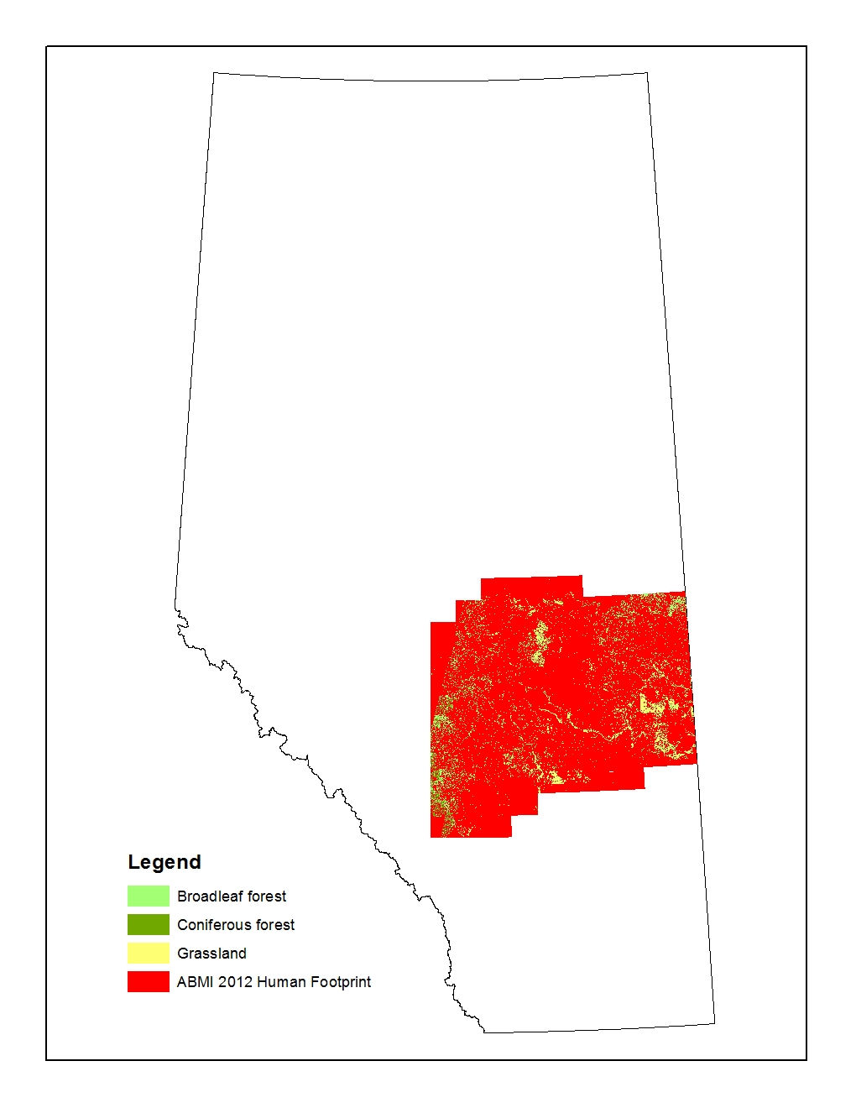
Figure 11 Extent of the Central Parkland Vegetation Inventory (CPVI) in Alberta showing natural vegetation types and human footprint for backfilling

Backfilling the CPVI layer
The CPVI polygons falling in the ABMI 2012 Human Footprint layer were assumed as human footprint. They were backfilled with the soil layer (see Section 6.4 for detailed information for this layer). The rules described in Table 15 in the above backfilling for GVI section.

Other polygons that were located outside the bounds of the ABMI 2012 Human Footprint layer and have no assigned natural vegetation types were overwritten (in order of precedence) by ABMILC and the dominant vegetation type in the natural subregion where they overlapped.

New Water Boundaries for the Backfilled CPVI layer
The open water polygons from CPVI were not kept. Instead, the more detailed polygons obtained from the Government of Alberta Base Layers for hydropoly and stream lines were stamped onto the backfilled CPVI layer. See detailed information for the open water polygon layer at Table 6 and Table 7 in Section 5.1.4.

Post cleaning up backfilled CPVI layer
Polygons with area <100m² were eliminated with the same information as its neighbouring polygon.

Vegetation in National Parks

Wood Buffalo National Park
The ecosite layer of Wood Buffalo Nation Park was firstly converted from the original raster format into a polygon layer. The area that fell in the AVIE extent was then clipped out. The natural vegetation types in the ecosite layer were renamed into more general types. The human footprint types, cloud and burn in the ecosite layer were backfilled. See Table 16 for details.

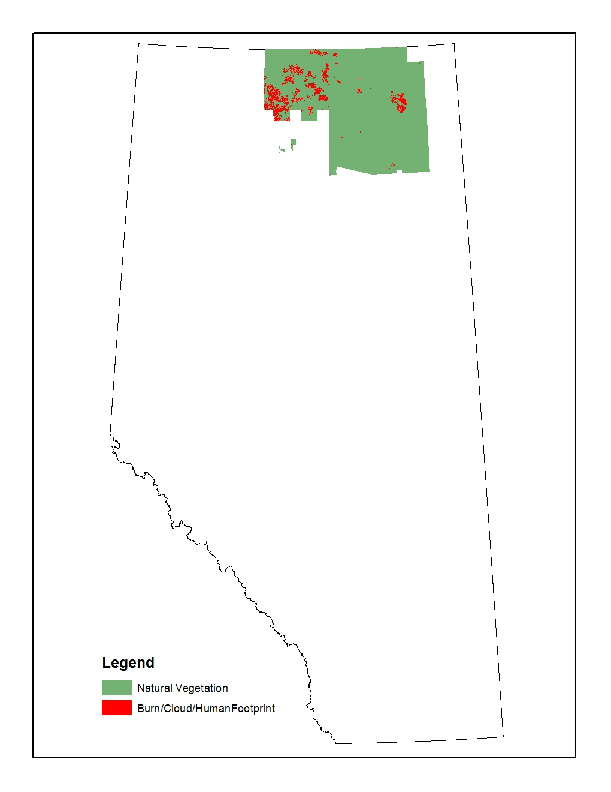
Figure 12 Extent of the Wood Buffalo National Park ecosite layer showing natural vegetation and Burn/Cloud/Human Footprint for backfilling

Table 16 Ecosite classes in the Wood Buffalo National Park ecosite layer and naming rules for natural vegetation types and backfilled rules for human footprint types
Grid code | Ecosite | Vegetation Type / (Backfilling Method)
0 and 59 | Unclassified | (The big polygon masking the no-data area was excluded. Other polygons were backfilled with neighboring vegetation type as “Linear” group in AVIE)
5 | Wetlands | ShrubSwamp
6 | Mud | Mud
7 | Sand | Sand
8 | Rock | Rock
9 | Cloud | (Backfilled with the same precedures as "others" group in AVIE)
10 | Cloud -shadow | (Backfilled with the same precedures as "others" group in AVIE)
11 | Water | Water
12 | Urban | (Backfilled with the same precedures as "others" group in AVIE)
14 | Access Major | (Backfilled with neighboring vegetation type as “Linear” group in AVIE)
16 | Agricultural | (Backfilled with the same precedures as "others" group in AVIE)
18 | Cut Block | (Backfilled with the same precedures as "others" group in AVIE)
19 | Burn | (Backfilled with the same precedures as "others" group in AVIE)
20 | Black Spruce | Black Spruce
21 | Jack Pine | Pine
22 | White Spruce | White Spruce
23 | Deciduous | Deciduous
24 | Deciduous Dominated | Deciduous
25 | Shrubby Poor Fen | ShrubFen
26 | Shrubby Rich Fen | ShrubFen
28 | Dwarf Birch/Sedge/Willow | ShrubSwamp
29 | Willow/Sedge | ShrubSwamp
30 | Willow/Reed Grass | ShrubSwamp
31 | Sedge Fen | GrassFen
32 | Reed Grass Fen | GrassFen
33 | Rare true grasslands on solonetzic or chernozemic soils | Grassland
34 | Cattail Wetlands | Marsh
35 | Reed Grass Wetlands | Marsh
36 | Bullrush na Wetlands | Marsh
37 | Sb-Pj hygric | Black Spruce
38 | Sb treed | Black Spruce
39 | Treed Bog | TreedBog
40 | Pj lichen | Pine
41 | Pj-Sb | Pine
42 | Pj-Aw blueberry | Pine
43 | Cranberry Sw | White Spruce
44 | Dogwood Sw | White Spruce
45 | Horsetail Sw | White Spruce
46 | Sw-Pj | White Spruce
47 | Aw(Bw) submesic | Deciduous
48 | Aw cranberry | Deciduous
49 | Pb-Aw dogwood | Deciduous
50 | Pb-Aw horsetail | Deciduous
51 | Aw-Sw blueberry | Deciduous
52 | Aw-Sw cranberry | Deciduous
53 | Pb-Sw dogwood | Deciduous
54 | Pb-Sw horsetail | Deciduous
55 | Treed rich fen | TreedFen
56 | Treed poor fen | TreedFen
57 | Shrubby Bog | ShrubBog
58 | Cutlines | (Backfilled with neighboring vegetation type as “Linear” group in AVIE)
60 | Immature Jack Pine | Pine

The backfilling procedures in the Wood Buffalo National Park ecosite layer were same as the procedures used in AVIE. The open water polygons from the Wood Buffalo National Park ecosite layer were not kept. Instead, the more detailed polygons obtained from the Government of Alberta Base Layers for hydropoly and stream lines were stamped onto the backfilled layer. See detailed information for the open water polygon layer at Table 6 and Table 7 in Section 5.1.4.

Elk Island National Park
The Vegetation Thematic Map of the Elk Island National Park created in 1996 was in the same format as AVI. This layer was appended into the AVIE layer. Some small gaps between the 2 layers were filled with the neighboring AVIE polygons. AVIE information was also used where the 2 layers were overlapped. The fields in the attribute table of AVIE but not in AVI were added to the Vegetation Thematic Map in order to match the fields of the AVIE layer. See detailed information for natural vegetation definition and human footprint backfilling for AVIE in Section 5.1.

Mountain National Parks

The Ecological Land Classification maps of the Banff National Park, Jasper National Park and Waterton Lakes National Park were first combined into a single layer. Each ecosite polygon in the Ecological Land Classification layer had one to three vegetation types. The dominant vegetation type (i.e., the first vegetation code in the vegetation column of the attribute table) was used to assign the polygons into the vegetation type (Table 17).

Table 17 Vegetation codes in the mountain national parks ecological land classification layer and naming rules for natural vegetation types
Vegetation Code in Ecological Land Classification Map | Description | Vegetation Type
C01 | Douglas fir/hairy wild rye | Douglas Fir
C02 | white spruce/fern moss | White Spruce
C03 | lodgepole pine/juniper/bearberry | Lodgepole Pine
C04 | white spruce/prickly rose/horsetail | White Spruce
C05 | white spruce-Douglas fir/feathermoss | White Spruce
C06 | lodgepole pine/buffaloberry/showy aster | Lodgepole Pine
C08 | black spruce-lodgepole pine/willow/sedge | Black Spruce
C09 | lodgepole pine/dwarf bilberry | Lodgepole Pine
C10 | lodgepole pine/green alder/feathermoss | Lodgepole Pine
C11 | lodgepole pine/feathermoss | Lodgepole Pine
C12 | Engelmann spruce-whitebark pine/false azelea | Engelmann Spruce
C13 | Engelmann spruce-subalpine fir/feathermoss | Engelmann Spruce
C14 | Englemann spruce-subalpine fir/false azalea | Engelmann Spruce
C15 | Englemann spruce-subalpine fir/grouseberry | Engelmann Spruce
C16 | aspen/hairy wild rye-peavine | Aspen
C17 | balsam poplar/buffaloberry | Balsam Popular
C18 | lodgepole pine/buffaloberry/grouseberry | Lodgepole Pine
C19 | lodgepole pine/buffaloberry/twinflower | Lodgepole Pine
C20 | lodgepole pine/false azalea/grouseberry | Lodgepole Pine
C21 | Engelmann spruce-subalpine fir/tall bilberry/liverwort | Engelmann Spruce
C22 | aspen/hairy wild rye-showy aster | Aspen
C23 | subalpine larch-subalpine fir/grouseberry-everlasting | Subalpine Larch
C24 | Engelmann spruce-subalpine fir/rock willow/white mountain heather | Engelmann Spruce
C26 | white spruce/buffaloberry/fern moss | White Spruce
C27 | whitespruce/prickly rose/fern moss | White Spruce
C28 | balsam poplar/horsetail | Balsam Popular
C29 | lodgepole pine/Labrador tea | Lodgepole Pine
C30 | Englemann spruce-subalpine fir/Labrador tea/crowberry | Engelmann Spruce
C31 | Englemann spruce-subalpine fir/hairy wild rye-heartleaf arnica-twinflower/feathermoss | Engelmann Spruce
C32 | Engelmann spruce/horsetail/feathermoss | Engelmann Spruce
C33 | Engelmann spruce/hairy wild rye | Engelmann Spruce
C34 | Engelmann spruce-subalpine fir/heather/feathermoss | Engelmann Spruce
C35 | lodgepole pine-(Engelmann spruce)/crowberry/lichen | Lodgepole Pine
C36 | lodgepole pine-white spruce/willow/hairy wild rye | Lodgepole Pine
C37 | whitespruce/buffaloberry/feathermoss | White Spruce
C60 | Populus tremuloides/Amelanchier alnifolia/Heracleum lanatum | Aspen
C61 | Populus tremuloides/Rubus parviflorus | Aspen
C62 | Populus tremuloides/Symphoricarpos occidentalis | Aspen
C63 | Populus tremuloides/Urtica dioica | Aspen
C64 | Pseudotsuga menziesii/Rubus parviflorus-Thalictrum occidentale-Arnica cordifolia | Douglas Fir
C65 | Pinus contorta/Arnica cordifolia-Spiraea betulifolia | Lodgepole Pine
C66 | Pinus contorta/Vaccinium membranaceum | Lodgepole Pine
C67 | Pinus contorta/Vaccinium myrtillus | Lodgepole Pine
C68 | Abies lasiocarpa-(Pinus contorta)/Xerophyllum tenax | Subalpine Fir
C69 | Picea engelmannii-Abies lasiocarpa-(Pseudotsuga menziesii)/Arnica cordifolia | Engelmann Spruce
C71 | Picea engelmannii-Abies lasiocarpa-(Pinus contorta)/Menziesia ferruginea/Arnica | Engelmann Spruce
C72 | Picea engelmannii-Abies lasiocarpa/Menziesia ferruginea/Vaccinium membranaceum | Engelmann Spruce
C74 | Picea engelmannii-Abies lasiocarpa/Menziesia ferruginea/fern | Engelmann Spruce
C75 | Larix lyallii/Luzula hitchcockii | Subalpine Larch
C76 | Populus trichocarpa | Black cottonwood
C78 | Picea engelmannii/Equisetum arvense | Engelmann Spruce
C79 | Pinus contorta/Calamagrostis rubescens-Aster conspicuus | Lodgepole Pine
H01 | mountain avens-snow willow-moss campion | Herbaceous
H02 | black alpine sedge-everlasting | Sedge
H03 | sedge-saxifrage | Sedge
H04 | mountain avens-kobresia-bearberry | Herbaceous
H05 | hairy wild rye-wild strawberry-fireweed | Grass
H06 | junegrass-pasture sage-wild blue flax | Grass
H07 | wheatgrass-pasture sage | Herbaceous
H08 | yellow dryad-willow herb | Herbaceous
H09 | mountain marigold-globeflower | Herbaceous
H10 | cottongrass/moss | Herbaceous
H11 | water sedge-beaked sedge | Sedge
H12 | Saxicolous lichen | Lichen
H13 | Richardson needlegrass-junegrass-everlasting | Grass
H14 | hairy wild rye-junegrass-bearberry | Grass
H15 | mountain avens-curly sedge | Herbaceous
H16 | fleabane-valerian | Herbaceous
H19 | bluebunch wheatgrass-hairy wild rye-showy aster | Grass
H20 | spotted saxifrage-hairy wild rye | Herbaceous
H24 | Bromus inermis-Phleum pratense | Grass
H25 | Danthonia spp.-Festuca scabrella-Koeleria macrantha | Grass
H27 | Agropyron spicatum-Festuca scabrella | Grass
H28 | Festuca scabrella-Arctostaphylos uva-ursi | Grass
H31 | Senecio triangularis-Erigeron peregrinus | Herbaceous
H37 | Polemonium viscosum-Saxifraga spp | Herbaceous
H42 | Agropyron spicatum | Grass
L01 | shrubby cinquefoil/bearberry-northern bedstraw | Shrub
L02 | juniper-willow | Shrub
L03 | Potentilla fruticosa/forb | Shrub
L04 | white mountain heather-mountain avens-snow willow | Shrub
L05 | heather-everlasting | Shrub
L06 | creeping juniper-northern wheatgrass-sedge | Shrub
L07 | arctic willow-cinquefoil | Shrub
O02 | limber pine-Douglas fir/juniper/bearberry | Douglas Fir
O03 | white spruce/shrubby cinquefoil/bearberry | White Spruce
O04 | Englemann spruce-subalpine fir-whitebark pine-lodgepole pine | Engelmann Spruce
O05 | Douglas fir/juniper/bearberry | Douglas Fir
O06 | Englemann spruce-supalpine fir/willow/ribbed bog moss | Engelmann Spruce
O07 | spruce/arrowgrass-sedge | White Spruce
O09 | Engelmann spruce-subalpine fir/valerian-fleabane | Engelmann Spruce
O10 | Engelmann spruce-subalpine fir/heather | Engelmann Spruce
O11 | spruce/Labrador tea/brown moss | White Spruce
O12 | Engelmann spruce-subalpine fir/rock willow/alpine bearberry | Engelmann Spruce
O14 | Engelmann spruce-subalpine fir/rock willow/bracted lousewort | Engelmann Spruce
O16 | paper birch/bearberry | Birch
O17 | white spruce/juniper/bearberry | White Spruce
O18 | Engelmann spruce-subalpine fir/willow/hairy wild rye | Engelmann Spruce
O19 | Engelmann spruce-subalpine fir/mountain avens | Engelmann Spruce
O25 | Pseudotsuga menziesii-Pinus flexilis-Pinus contorta/Arctostaphylos uvaursi-Juniperus communis | Douglas Fir
O26 | Pseudotsuga menziesii-Pinus contorta/Arctostaphylos uva-ursi-Festuca scabrella | Douglas Fir
O27 | Pinus flexilis/Arctostaphylos uva-ursi | Limber pine
O28 | Picea engelmannii-Abies lasiocarpa-Pinus albicaulis/Shepherdia canadensis | Engelmann Spruce
O29 | Picea engelmannii-Abies lasiocarpa/Luzula hitchcockii-herb | Engelmann Spruce
O30 | Pinus albicaulis-Abies lasiocarpa/Luzula hitchcockii-Vaccinium myrtillus | White bark pine
O31 | Pinus albicaulis-Picea engelmannii/Dryas octopetala | White bark pine
O32 | Abies lasiocarpa/Valeriana sitchensis-Pedicularis bracteosa-Thalictrum occidentale | Subalpine Fir
S01 | dwarf birch-shrubby cinquefoil-willow/brown moss | Shrub
S02 | subalpine fir-willow | Shrub
S03 | dwarf birch-shrubby cinquefoil/needlerush | Shrub
S04 | willow-dwarf birch/fleabane | Shrub
S06 | willow-green alder/bluebell | Shrub
S07 | willow/horsetail | Shrub
S08 | willow/cinquefoil | Shrub
S09 | dwarf birch-willow/kobresia | Shrub
S10 | willow-dwarf birch-shrubby cinquefoil | Shrub
S11 | willow/timber oatgrass | Shrub
S12 | willow/hairy wild rye | Shrub
S13 | Alnus crispa/fern | Shrub
S24 | Betula glandulosa-Potentilla fruticosa-Salix spp./Carex spp | Shrub
S25 | Salix glauca/herb | Shrub

The un-vegetated ecosite polygons were assigned the natural types as Table 18.

Table 18 Un-vegetated ecosite codes in the mountain national parks ecological land classification layer and the natural types assigned
Ecosite | description | Vegetation Type
CL | Colluvial landslide, non soil or regosolic soil, sparsely vegetated | Bare
CR | Colluvial rubble, non soil or regosolic soil, unvegetated or sparsely vegetated | Bare
GL | Glacier, non soil, unvegetated | Glacier
M | Recent Moraine, non soil or regosolic soil, unvegetated or sparsely vegetated | Rock
P | pits, quarries, and landfill sites | (backfilled types)
R | Rockland, nonsoil, unvegetated or sparsely vegetated | Rock
RG | Rock Glacier.non soil or regosolic soil, unvegetated or sparsely vegetated | Bare
SC | Recent stream channel, regosolic soil and Gleysolic soil, unvegetated or sparsely vegetated | Bare
T | Talus, non soil or regosolic soil, unvegetated or sparsely vegetated | Rock
ZZ | Water | Water
M+GL |  | Rock
R+CR |  | Rock
R+GL |  | Rock
R+T |  | Rock
T+GL |  | Rock
T+M |  | Rock
T+RG |  | Rock
M+R |  | Rock

Data for the MOIST_REG field was derived from the soil drainage information . A conversion rule was developed to convert the dominant natura into the ABMI moist regime.

Table 19 Conversion from the soil drainage in the mountain national parks ecological land classification layer to the ABMI moisture regime
Soil Drainage | Ranges of Drainage | Description | ABMI Moisture Regime
2 | 2-3 | Rapidly Drained | Xeric
3 | 2-4 | Well Drained | Sub-Mesic
4 | 3-4 | Moderately Well Drained | Mesic
5 | 4-6 | Imperfectly Drained | Hygric
6 | 5-6, 5-7 | Poorly Drained | Sub-Hydric
7 | 6-7 | Very Poorly Drained | Hydric

The polygons with ecosite type “P”, which represented pits, quarries, and landfill sites, were backfilled with neighboring vegetation type and moisture regime.

The open water polygons (Ecosite ZZ) in MTNPs were combined with more detailed polygons obtained from the Government of Alberta Base Layers for hydropoly and stream lines. This detailed open water polygon layer was stamped onto the backfilled MTNP layer. All open water polygons from the original MTNP layer that fell outside of the new open water boundaries (i.e., from the Government of Alberta Base Layer Database) were retained as water.

Remaining Areas
The areas outside the extents of AVI, PLVI, GVI, CPVI and National Parks were backfilled in order of precedence by Phase1, ABMILC, soil layer (applied in ABMI 2012 HF extent only), and dominant vegetation type in the natural subregion where they overlapped.

The open water polygons derived from the Government of Alberta Base Layers for hydropoly and stream lines were stamped onto the backfilled remaining area. See detailed information for the open water polygon layer at Table 6 and Table 7 in Section 5.1.4.

The cutblock polygons in the 2012 human footprint layer were used to clip the areas outside of the AVIE. These polygons were backfilled with the same procedures as for backfilling the AVIE layer.

Data Additions
Additional data were added to the attribute table for each polygon to increase its usefulness as a vegetation map of Alberta and to aid ABMI analyses. The supplementary data included information on the percentage of pine (PCT_P), polygon year of origin (ORIGIN_YEAR), and soil type (SOIL_TYPE). Additional information about water and wetland was also added.

Pine (PCT_P)
Information regarding the location of pine throughout Alberta was obtained from two main sources:
- Extended AVI layer (AVIE, provided by AESRD in January, 2014), and
- Alberta Ground Cover Characterization (AGCC, provided by the Earth Observation Systems Laboratory at the University of Alberta).

Data from the AVIE layer were preferentially used in areas where it was available. Pine information in AVIE cutblocks was based on backfilled info (see above). Data from the AGCC layer were used in areas outside of the AVIE boundary.

Processing the AVIE layer

- Polygons in the AVIE layer in which PCT_P was >0 or UPCT_P was >0 if understory is dominant were selected.
- Cutblock polygons were first backfilled with preharvest vegetation types (see Section 5.1.3.5). The cutblocks with backfilled types as Pine were selected. The PCT_P value was coded as 9 (i.e., corresponding to a polygon comprised of 90% pine).
- The layer created by Step 1 was ‘stamped’ onto the layer in Step 2.

Processing the AGCC layer
- A new pine layer was created by selecting AGCC polygons coded as either ‘52’ or ‘152’.
- The boundaries of the AVIE polygon layer was used to clip the AGCC pine layer created in step 1 to generate a new raster layer limited to pine data for areas beyond the AVIE boundary.
- The clipped AGCC layer was converted from raster format to a vector layer.
- Polygons >0.5 ha were selected from Step 3.
- The layer in step 4 was clipped with Grassland and Parkland Natural Region boundaries to ensure no pine from AGCC layer occurred within those Regions.

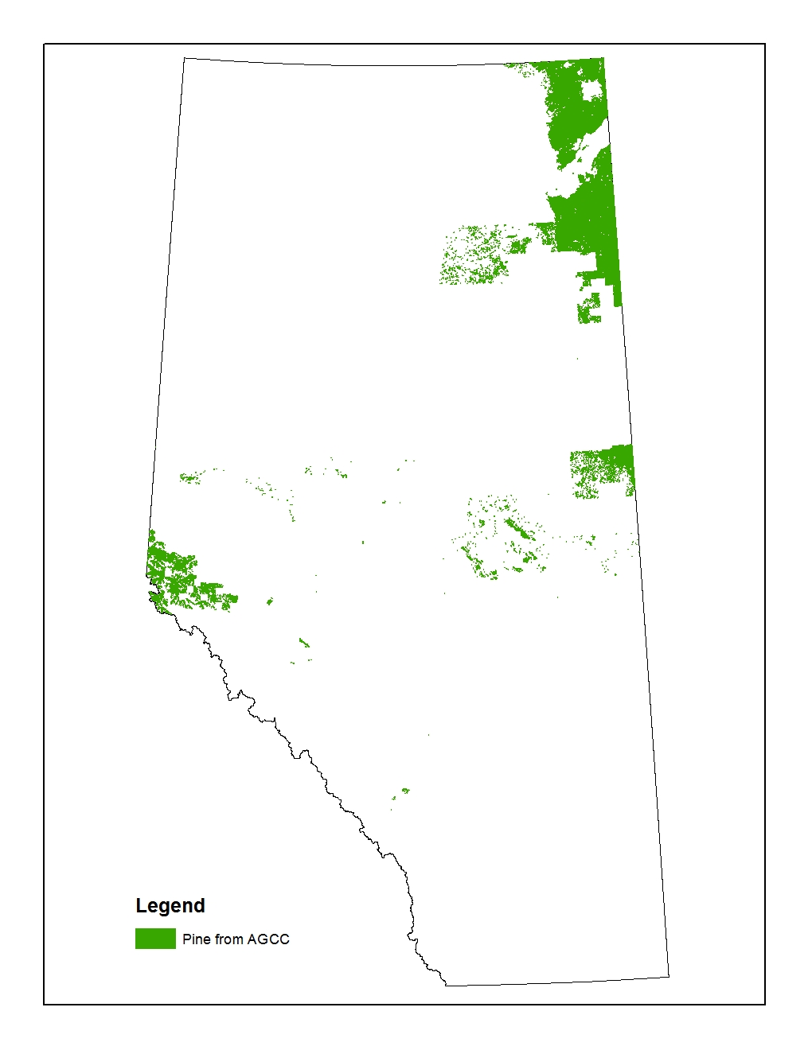
Figure 13 Extent of the pine from AGCC

Combining layers
The pine sub-layers from Sections 6.1.1 (AVIE) and 6.1.2 (AGCC) above were combined to a single layer representing the location of pine throughout the Province. The data values include -1, 0, 1-10, 52, 152, and 252. Values 1-10 indicates the percentage of pine canopy cover from 10 to 100% respectively from AVIE (where 1 = 10%, 2 = 20%, …, and 10 = 100%). Values of ‘52’ and ‘152’ are from the AGCC layer; ‘52’ refers to ‘Closed Pine’ and ‘152’ refers to ‘Open Pine’ areas. Values of ‘252’ are those polygons classified as “Pine” in PLVI, GVI, or in the national park layers. Value 0 refers to polygons with no pine in AVIE extent and value -1 refers to polygons with no pine outside of AVIE extent.

Water and Wet Information
The water and wet information from multiple data sources was assembled in the fields of VEG_TYPE, MOIST_REG, WET, WET_SOURCE, CWCS_CLASS, and CWCS_EXTENT of the backfilled vegetation layer (Table 20).

Water polygons from the source layers were coded as “Water” and stored in Field Veg_Type together with the vegetation types. The detailed water types in the Hydropoly layer and Stream Lines layer were stored in the Field “WET” and were coded as “Hydro” in the Field “WET_SOURCE”.

Moisture regime information from AVI, GVI , PLVI, and MTNP layers were stored in a single field MOIST_REG. Alberta CWCS Merged Wetland Inventory layer were stored in the Field of CWCS_CLASS and Field CWCS_EXTENT.

Table 20 Source layers of water and wetland information and the fields they stored.
 | Source layer | Data Extraction Rule Set | Fields Stored
Water | Hydropoly | All data excluding FEATURE_TY is 'ISLAND-LAKE', 'ISLAND-RECUR', and 'ISLAND-RIV' | WET, VEG_TYPE
 | Stream Lines buffered layer | All records | WET, VEG_TYPE
 | AVI | NAT_NON is River (NWR) or Lake (NWL) | VEG_TYPE
 | GVI | GVI Site Type 5 (LenW) + Site Type 6 (LtcR)>=80% | VEG_TYPE
 | PLVI | SiteType1 = ‘NW” and SitePct1 >=8 | VEG_TYPE
 | MTNP | Ecosite Type = ‘ZZ’ | VEG_TYPE
Wet | Alberta CWCS Merged Wetland Inventory | All records with 5 wetland types (Marsh, Open Water, Bog, Fen, Swamp) | CWCS_CLASS,  CWCS_EXTENT
 | AVI | All records with all moisture regime codes (a-aquatic, m-mesic, w-wet, d-dry) | MOIST_REG
 | GVI | All records with all ABMI moisture regime codes (Dry, Mesic, OpenWater, Wet) derived from dominant natural site type | MOIST_REG
 | PLVI | All records with all Map Code 1 | MOIST_REG
 |  | All records with the wetland Site Type1 (WT-Treed Bog, WS-Shrub Bog, TF-Treed Fens, SF – Shrub Fens, GF – Grass Fens, M – Marsh, SW – Swamp) | MOIST_REG,  WET
 | MTNP | All records with all ABMI moisture regime codes (Xeric, Sub-Mesic, Mesic, Hygric, Sub-Hydric, Hydric) derived from soil drainage | MOIST_REG

Only Alberta CWCS Merged Wetland Inventory layer is described below. All other source layers listed in Table 20 have been described in the above sections.

Alberta CWCS Merged Wetland Inventory

The Alberta CWCS Merged Wetland Inventory (Figure 14) is a polygon layer with five classes of wetland defined according to the Canadian Wetland Classification System (CWCS). The five classes are 1) marsh, 2) open water, 3) bog, 4) fen, and 5) swamp.

This layer contained data from four sources:
- Ducks Unlimited Canada (DUC)-Boreal Enhanced Wetland Classification System (EWC). The minimum mapping unit was 1 ha.
- Landsat-Canadian Wetland Classification System (CWCS). The minimum mapping unit was 1 ha.
- SPOT (Systeme Pour l'Observation de la Terre) Grassland Vegetation Inventory (GVI) Lentic Classification. The minimum mapping unit was 0.04 ha.
- High resolution (1:15,000 to 1:30,000 scale) air photography. The minimum mapping unit was 0.02 ha.

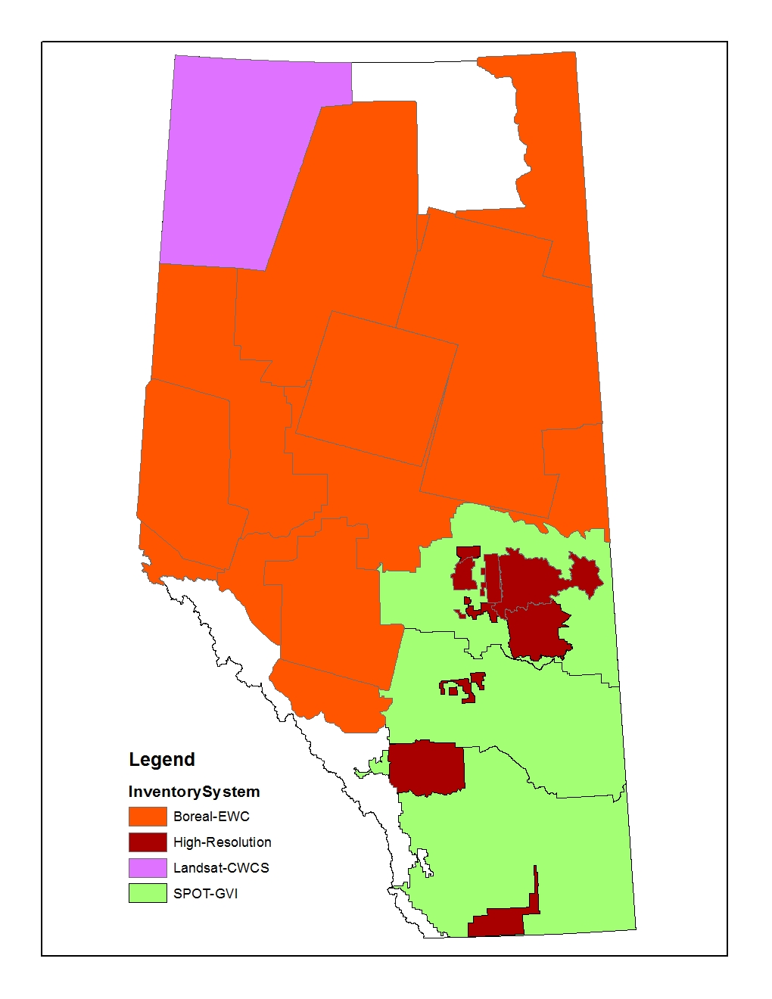
Figure 14 Distribution of wetlands contained within the Alberta CWCS Merged Wetland Inventory layer. Colors represent individual sources of data (purple: Landsat-CWCS, red: DUC-EWC, green: SPOT-GVI, dark brown – High-Resolution, and white: no data).

The information in the fields of CWCS_Class and Extent of the original layer was stored in the field of CWCS_CLASS and CWCS_EXTENT of the backfilled layer respectively.

Date of Origin (ORIGIN_YEAR)
A sub-layer was created that described the year of polygon origin throughout Alberta. This information was added to the backfilled layer as two new fields (ORIGIN_YEAR, ORIGIN_TYPE).

The sub-layer was derived from three primary data sources:
- Extended AVI Layer (AVIE),
- PLVI
- Provincial Historical Wildfire Data Layer.

The ‘year of origin’ information for the backfilled Cutblocks (see Section 5.1.3.2) was also added to this sub-layer. The processing steps for the AVIE and PLVI were described in Sections 5.1.1 and section 5.2.1 respectively. The steps for wildfire data are described below.

This historical wildfire layer was originally organized as an overlapped single layer for all years from 1931 to 2013. A non-overlapped layer was created by:
- First, the ORIGIN_YEAR and ORIGIN_TYPE fields were added to the attribute table of the layer. The ORIGIN_TYPE was coded as “SRD_FIRE” and the value of ORIGIN_YEAR was copied from the field YEAR.
- Next, the layer was “entangled” into 83 yearly single layers from 1931 to 2013 individually.
- Then the 1931 layer was “stamped” by the 1932 layer.
- The resultant combined layer of 1931-1932 from Step 3 (above) was “stamped” by the 1933 layer from Step 2.
- The general process in 3) and 4) above was repeated with each layer being stamped (updated) by the layer from the following year. This process ended when the 1930- 2012 combined layer was stamped by the 2013 layer.
Where year of origin information was available from AVIE or PLVI, this was used in preference to wildfire data. However, when the AVI/PLVI image year was older than the wildfire year, the year of origin information derived from Fire was stamped over the origin information derived from AVIE and PLVI.

Soil Type (SOIL_TYPE)
A new sub-layer was created that described the soil type for polygons in the Grassland, Parkland and Dry Mixedwood Natural Regions/Subregions. The soil type data was critical for backfilling vegetation into cultivated and developed areas (see section Error! Reference source not found.). Overall, there were six wetland and eighteen natural upland GVI soil types (24 types in total; see Table 21).

Table 21 Soil Types from the Grassland Vegetation Inventory (GVI) layer.
Primary Class | Land Sub-Class | Site Type | Description | Soil Type Code
Open Water | Lentic | Standing water | Permanent open standing-water with no emergent vegetation, generally larger than 1.0 ha and >15 cm deep. | LenW
 | Lotic | River | Open water of rivers, generally rivers wider than 20 m. | LtcR
Native / Natural  Lentic | Lentic | Temporary | Water present <3 weeks (dry by July) <15 cm deep. | LenT
 |  | Seasonal | Water usually present >3 weeks (usually dry by July) >15 cm deep. | LenS
 |  | Alkali | Water present >3 weeks and >15 cm deep | LenA
 |  | Semi-Permanent to Permanent | Throughout the year except during periods of extreme drought (present in autumn in 70% of the years); often occurs adjacent to LenW; includes the march zones; water is generally >15 cm deep; if open water is present it is smaller than 1.0 ha | LenSP
Native / Natural  Lotic | Lotic | Coniferous | Coniferous trees with a combined canopy cover of greater than 25%. | LtcC
 |  | Deciduous | Deciduous trees with a combined canopy cover of greater than 25%. | LtcD
 |  | Shrub | Shrubs have a combined cover of at least 10%. | LtcS
 |  | Herbaceous | Herbaceous species (including sedges) have a combined cover of at least 5%. | LtcH
Native / Natural  Grassland | Grassland | Subirrigated | Water table is close to surface during growing season, but rarely above. Does not have a defined depressional edge. | Sb
 |  | Overflow | Areas subject to water spreading and sheet flow. Typically on gentle inclines or terraces above the frequent flood zone. For locations where flood frequency is less than once every ten years. | Ov
 |  | Clayey | Clayey-textured soils including silty clay, sandy clay, clay, and heavy clay. Generally >40% clay. | Cy
 |  | Loamy | Includes loam, silt loam, silt, clay loam, sandy clay loam, and silty clay loam. | Lo
 |  | Sandy | Sandy-loam-textured soils. | Sy
 |  | Limy | Eroded or immature soils with free lime (CaCO₃) at the soil surface. Soil pH generally >7.5. | Li
 |  | Sand | Loamy sand and sand soils, and not with a duned surface. | Sa
 |  | Blowouts/ Solonetzic Order | Areas with Solonetzic (hardpan) soils. The surface may or may not have eroded pits. | BlO
 |  | Choppy Sandhills | Loamy sand and sand soils with a duned land surface. | CS
 |  | Thin Breaks | Areas with bedrock at or near the soil surface. Amount of vegetation is intermediate between Limy and Badlands. TB may include thin, eroded or immature soils on gentle to steep slopes. | TB
 |  | Shallow to Gravel | Soil with 20 to 50 cm of a sandy or loamy surface overlying a gravel or cobble- rich substrate. | SwG
 |  | Saline Lowland | Areas with negligible vegetation due to electrical conductivity (salts) and/or sodium adsorption ratio limitations. | SL
 |  | Gravel | Dominated by gravels or cobbles (>50% coarse fragments). May be covered by a mantle <20 cm thick with some gravels. | Gr
 |  | Badlands/ Bedrock | Nearly barren or barren lands, with exposures of soft rock, hard rock, or surficial geology. Includes steep valley walls. | BdL

Soil type information was combined from two sources (Figure 15):

- A geodatabase that provided detailed soil type information across eleven map units, each with a single layer. These 11 maps were cleaned and merged into a single layer.
- The soil types in the areas outside of the boundaries of the detailed soil information (#1 above) were derived from the Agricultural Region of Alberta Soil Inventory Database (AGRASID 30) by Ron McNeil in LandWise Inc.

The layers from source 1 and source 2 were merged into a single soil type layer.

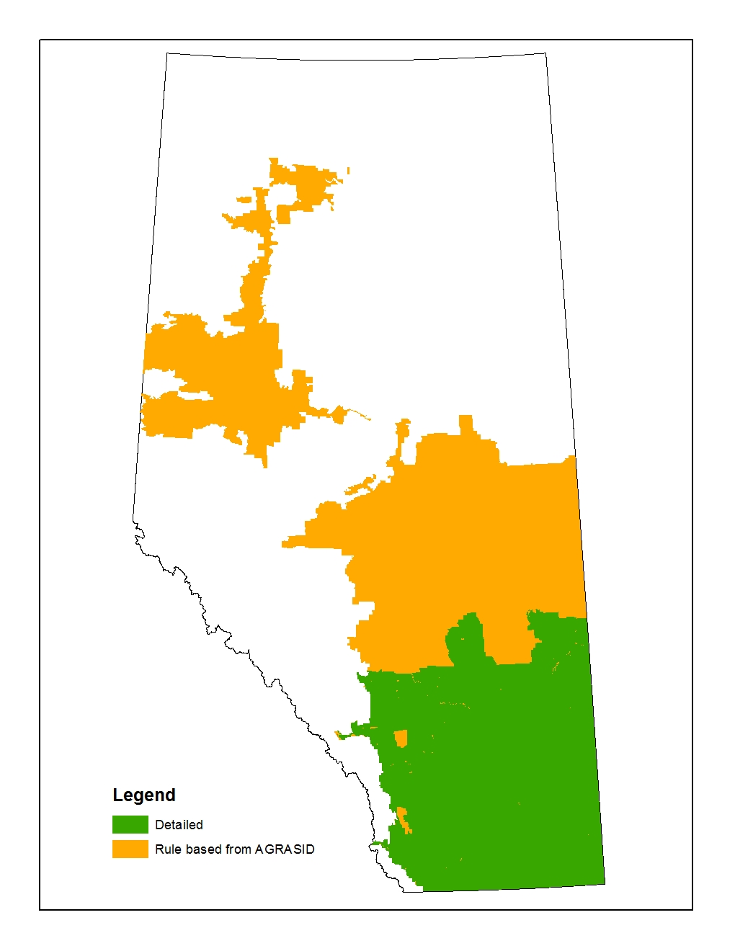
Figure 15 Extent of soil type information derived from 1) the SRD geodatabase ‘GVI_sitetypes_from_soils.gdb’ (green) and 2) AGRASID layers (brown).

Combination of Sub-Layers

The six GIS sub-layers described in Section 6 (Pine, Origin, Hydro Water, moisture regime, Alberta CWCS merged wetland, and soil) were combined with the original vegetation layer described in Section 5. Within the attribute table (Figure 16), the field VEG_TYPE records the vegetation classes, and the field HABIT records both upland and wetland vegetation classes. The steps involved in data processing for the field HABIT is described below.

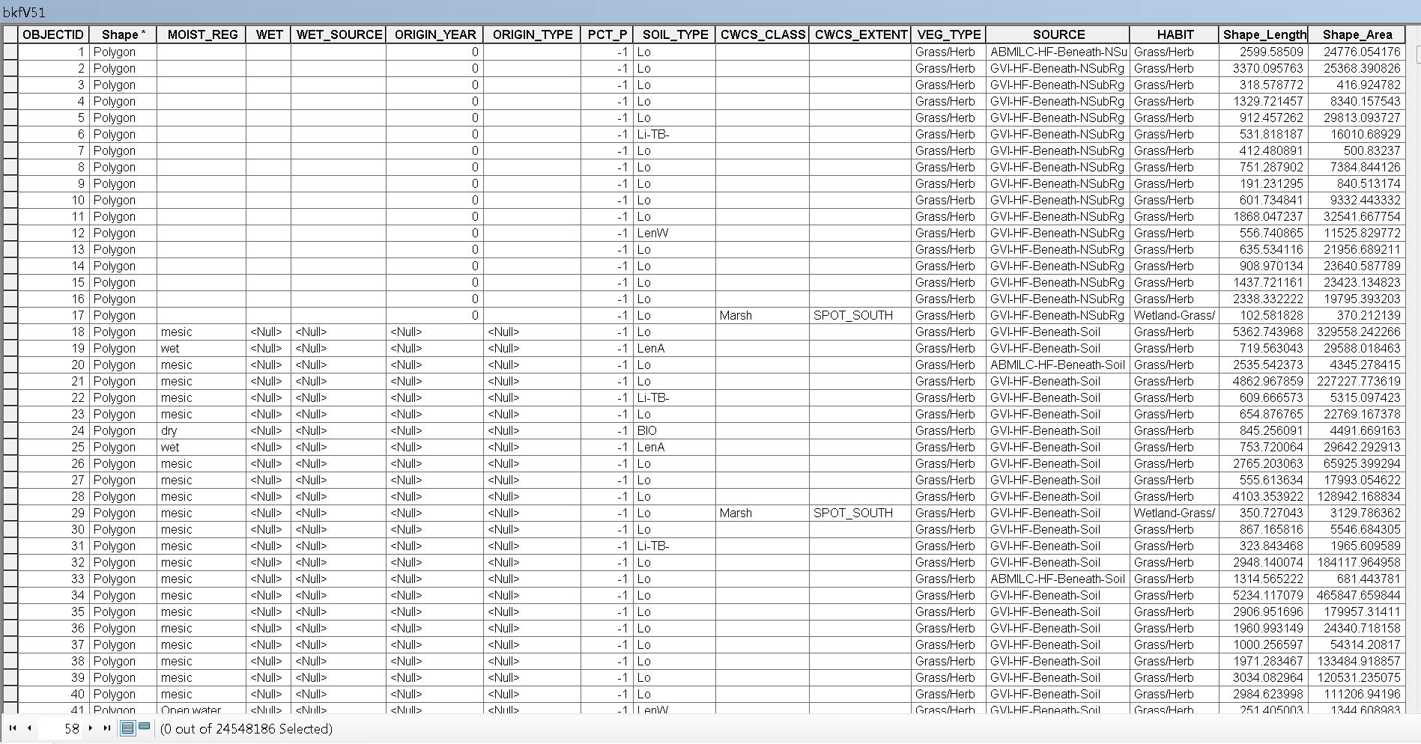
Figure 16 Attribute table of the backfilled vegetation layer.

The backfilled layer is available two formats: 1) a single layer that spans all of Alberta, and 2) a tiled version.

Upland and Wetland Habitat Definition

To define the wetland types, the vegetation types in the field VEG_TYPE were firstly simplified and stored in a temporary field. The conversion rules are list in Table 22.

Table 22 Conversion rules from VEG_TYPE to simplified vegetation type.
VEG_TYPE | Simplified Veg Type
Alkali | Grass/Herb
Aspen | Decid
Balsam Popular | Decid
Bareland | Non-Veg
Black Spruce | BSpr
Black cottonwood | Decid
Coniferous | Conif
Deciduous | Decid
Douglas Fir | Conif
Engelmann Spruce | Conif
Fir | Conif
ForestUnidentifiedType | Decid
Grass/Herb | Grass/Herb
Larch | Larch
Lodgepole Pine | Pine
Lotic Herb | Grass/Herb
Lotic Shrub | Shrub
Marsh | Grass/Herb
Mixedwood | Mixwood
Mud | Non-Veg
MuskegMarsh | BSpr
Pine | Pine
Rock/Rubble | Non-Veg
Sand | Non-Veg
Sedge | Grass/Herb
Shrub | Shrub
ShrubBog | Shrub
ShrubFen | Shrub
ShrubSwamp | Shrub
Snow/Ice | Non-Veg
Subalpine Fir | Conif
Subalpine Larch | Conif
Swamp | Decid
TreedBog | BSpr
TreedFen | Larch
Water | Water
White Spruce | Conif

Three steps were performed in order to identify the wetland. Step 1 was to identify wetland from the information in the simplified vegetation field only. Those polygons are always wetland, regardless of the moisture information (Table 23).

Table 23 Conversion rules from simplified vegetation only to the wetland type
Simplified Vegetation Type | Wetland Type
Black Spruce | Wetland – BSpr
MuskegMarsh | Wetland – BSpr
Larch (excluding Subalpine Larch) | Wetland – Larch
Black cottonwood | Swamp – Decid
Swamp | Swamp – Decid
Lotic Shrub | Wetland – Shrub
Alkali | Wetland - Grass/Herb
Lotic Herb
Sedge
Marsh

Step 2 was to identify the wetland polygons when a vegetation type can occur in both upland and wetland areas (e.g., Shrubs). Within AVI, PLVI, EINP, MTNP and WBNP where sufficient resolution of information about moisture was available, both vegetation type and moisture regime were used to define the wetland types (Table 24). In all areas in Alberta where no moisture regime information, both vegetation type and CWCS_CLASS were used to define the wetland types (Table 25). Note, even within the extent of AVI, PLVI, EINP and WBNP, some polygons had no moisture regime because these polygons were backfilled from the beneath layers of Phase1, ABMILC and Natural sub-region.

Table 24 Conversion rules from both simplified vegetation and moisture to the wetland type
MOISTURE_REG | Simplified Vegetation Type | Wetland Type
w, wet, a, Sub-Hygric, Hygric, Sub-Hydric, Hydric, 6C, 6D, 6E, 7B, 7C, 7D, 9B, 9C, 9D, 9E | Conif | Swamp - Conif
 | Decid | Swamp - Decid
 | Mixwood | Swamp - Mixwood
 | Pine | Swamp - Pine
 | Shrub | Wetland - Shrub
 | Grass/Herb | Wetland - Grass/Herb
 | Bare | Wetland - Bare

Table 25 Conversion rules from both simplified vegetation and CWCS to the wetland type
Natural Region/ Sub-Region | CWCS_Class | Simplified Vegetation Type | Wetland Type
Grassland, Parkland, Dry Mixedwood | Swamp | (any) | Wetland - Decid
 | Marsh | (any) | Wetland - Grass/Herb
(Other natural regions/sub-regions) | Swamp, Bog, Fen, Marsh | Conif | Swamp - Conif
 |  | Decid | Swamp - Decid
 |  | Mixwood | Swamp - Mixwood
 |  | Pine | Swamp - Pine
 |  | Shrub | Wetland - Shrub
 |  | Grass/Herb | Wetland - Grass/Herb
 |  | Bare | Wetland - Bare

Step 3 was to identify open water. Type Water in field VEG_TYPE, which was derived from Hydro layers as well as the layers of AVIE, PLVI, MTNP, EINP and GVI, were copied into the field HABIT. In addition, the Open water class in CWCS_CLASS was also copied into the field HABIT if the polygon was in Grassland, Parkland, and Dry Mixedwood natural regions/Sub-Regions as detailed information about small wetlands and open water are available for southen Alberta within CWCS_CLASS.

Attribute Table Definitions

MOIST_REG
Definition: Moisture regime information from AVIE, PLVI, MTNP, EINP and GVI.
Values: Categorical values. a, m, w, d from AVIE and EINP. Xeric, Sub-Mesic, Mesic, Hygric, Sub-Hydric, Hydric from MTNP. dry, mesic, wet, Open water from GVI. See Section 5.2.1 for PLVI map code.

ORIGIN_YEAR
Definition: Year of last known disturbance in which vegetation age would have been reset to zero.
Values: 0, NULL and Integers between 1520 and 2013. The values 0 and NULL refer to area that does not have information on the year of last disturbance or is not a forest stand.

ORIGIN_TYPE
Definition: Data source for ORIGIN_YEAR field.
Values: Categorical values are: SRD_Fire, PLVI, AVIE_CUT_bk, AVIE_mod1, AVIE_mod2, AVIE_Origin, AVIE_Other_bk, AVIE_PEAT_bk, AVIE_RecentBurn_PhotoYear, AVIE_umod1.

PCT_P
Definition: Percentage of pine; based on canopy cover.
Values: -1, 0, 1-10, 52, 152, and 252. Values 1-10 indicates the percentage of pine canopy cover from 10 to 100% respectively from AVIE (where 1 = 10%, 2 = 20%, …, and 10 = 100%). Values of ‘52’ and ‘152’ are from the AGCC layer; ‘52’ refers to ‘Closed Pine’ and ‘152’ refers to ‘Open Pine’ areas. Values of ‘252’ are those polygons classified as “Pine” in PLVI, GVI, or in the national park layers. Value 0 refers to polygons with no pine in AVIE extent and value -1 refers to polygons with no pine outside of AVIE extent
WET
Definition: Detailed water types in Hydro layers, as well as PLVI wetland types.
Values: Categorical values. See Table 6, Table 7 for water types. PLVI wetland types are WT, WS, TF, SF, GF, M, SW.

WET_SOURCE
Definition: Data source for WET field.
Values: Categorical values are: Hydro, PLVI.

SOIL_TYPE
Definition: Soil type based on GVI and AGRASID data.
Values: Categorical; see Table 21.

CWCS_CLASS
Definition: Alberta merged CWCS wetland types.
Values: Categorical values are Marsh, Open Water, Bog, Fen, Swamp

CWCS_EXTENT
Definition: Extent field from the Alberta merged CWCS wetland layer.
Values: Categorical; see the layer document for detail.

VEG_TYPE
Definition: Backfilled vegetation classes
Values: Categorical; Alkali, Aspen, Balsam Popular, Bareland, Black cottonwood, Black Spruce, Coniferous, Deciduous, Douglas Fir, Engelmann Spruce, Fir, ForestUnidentifiedType, Grass/Herb, Larch, Lodgepole Pine, Lotic Herb, Lotic Shrub, Marsh, Mixedwood, Mud, MuskegMarsh, Pine, Rock/Rubble, Sand, Sedge, Shrub, ShrubBog, ShrubFen, ShrubSwamp, Snow/Ice, Subalpine Fir, Subalpine Larch, Swamp, TreedBog, TreedFen, Water, White Spruce

HABIT
Definition: Backfilled vegetation classes including both upland and wetland types
Values: Categorical; Conif, Decid, Grass/Herb, Mixwood, Non-Veg, Pine, Shrub, Swamp-Conif, Swamp-Decid, Swamp-Mixwood, Swamp-Pine, Water, Wetland-Bare, Wetland-BSpr, Wetland-Decid, Wetland-Grass/Herb, Wetland-Larch, Wetland-Shrub.

SOURCE
Definition: Source layer and backfilled method for the vegetation information
Values: Categorical. Four parts divided by “-“, such as AVIE-AIF-DomInBuf50m-AVIE. The first part (i.e., AVIE) is the extent the polygon located. The second part (i.e.,AIF) is the HF type. The third part (i.e., DomInBuf50m) is the method used for backfilling. The last part is the layer used for backfilling (i.e., AVIE).

Addition of ABMI 2012 Human Footprint Sub-layers

The 21 human footprint sub-layers of the ABMI 2012 Human Footprint Layer (Version 3) were combined into 8 layers first (Table 26). Each of the 8 layers was then “stamped” onto the backfilled layer created in Section 7. The attribute table of this layer is the same as for the backfilled layer with the addition of the 8 human footprint group’s fields, field ‘FEATURE_TY’ which records the human footprint chosen from the 8 fields by referring to the original order of 2012 Human Footprint layer, and field “CutYear” which records the year of harvest for cutblock polygons.

Table 26 Eight groups combined from 21 ABMI 2012 Human Footprint Sub-layers
Field Name of HF Group | Original Order in HF2012 | HF Sub-Layer
HydroHF | 1 | Reservoirs
 | 2 | Borrow Pits, Sumps, Dugouts and Lagoons
 | 5 | Canals
RoadRail | 3 | Non-Vegetated Impermeable Surfaces (Roads)
 | 4 | Rail Lines Hard Surface
 | 6 | Vegetated Surfaces of Roads, Trails and Railways
MineCFOAgCutblock | 7 | Mine Sites
 | 14 | CFO and other High Density Livestock
 | 17 | Cultivation
 | 18 | Cut Blocks
IndHighLow | 8 | Industrial Sites
Well | 9 | Well Sites (Energy) ACTIVE
 | 16 | Well Sites (Energy) ABANDONED
LandFRecWindMRes | 10 | Landfill
 | 11 | Recreation and Other Vegetated Facilities
 | 12 | Wind Generation Facility
 | 15 | Urban and Rural Residential
 | 21 | Disturbed Vegetation
TransPipe | 13 | Transmission Lines
 | 19 | Pipelines
Cutline | 20 | Seismic Lines

The backfilled layer with the added 2012 human footprint is available two formats: 1) a single layer that spans all of Alberta, and 2) a tiled version.

Source: Environment and Sustainable Resource Development, Government of Alberta; URL: http://esrd.alberta.ca/forms-maps-services/maps/resource-data-product-catalogue/forest-vegetation-inventories.aspx
The ABMILC layer filename is ABMIw2wLCV2000 (Version 2.1) and may be download from http://abmi.ca.
Source: Parks Canada Agency. Unpublished Data. Reproduced with the permission of Parks Canada Agency. This product was produced by or for the Alberta Biodiversity Monitoring Institute based on data provided by Parks Canada Agency.
The Alberta base features layer contained higher resolution data on water polygon features.
Description available at: http://esrd.alberta.ca/lands-forests/documents/AVI-ABVegetation3-InventoryStan-Mar05.pdf
Environment and Sustainable Resource Development, Government of Alberta; URL: esrd.alberta.ca
Available from: http://esrd.alberta.ca/forms-maps-services/maps/resource-data-product-catalogue/biophysical.aspx
http://www.eosl.eas.ualberta.ca/index.html
Data for pine are contained within the PCT_P field of the backfilled layer.
The layer and associated metadata may be downloaded from: http://srd.alberta.ca/MapsPhotosPublications/Maps/ResourceDataProductCatalogue/Biophysical.aspx
National Wetlands Working Group. 1997. The Canadian Wetland Classification System, 2nd Edition. Warner, B.G. and C.D.A. Rubec (eds.), Wetlands Research Centre, University of Waterloo, Waterloo, ON, Canada. 68 p.
The AVIE layer was provided by Bev Wilson from AESRD (August, 2012).
Downloadable from: http://www.srd.alberta.ca/Wildfire/WildfireStatus/ HistoricalWildfireInformation/SpatialWildfireData.aspx.
The layers were combined using the ‘Update’ command in ArcGIS.
The geodatabase (“GVI_sitetypes_from_soils.gdb”) was provided by O. Castelli from SRD in Lethbridge, AB.
Downloaded from: http://www1.agric.gov.ab.ca/$department/deptdocs.nsf/all/sag3252?opendocument
The layers were combined using the ‘Union’ command in ArcGIS.
The ArcGIS commend ‘Update’ was used in this step.

